电子/电路

工程科技

**使用dsPIC DSC实现数字电源转换非线性预测和自适应控制算法**

使用dsPIC DSC实现数字电源转换非线性预测和自适应控制算法

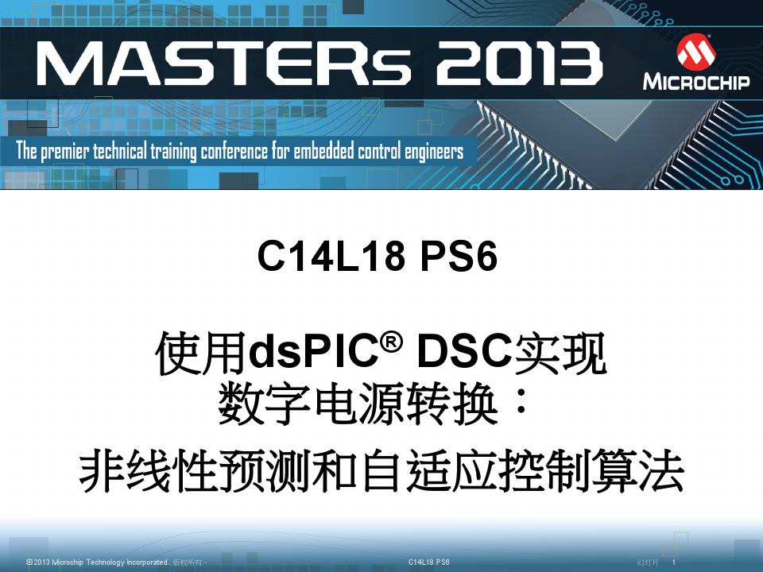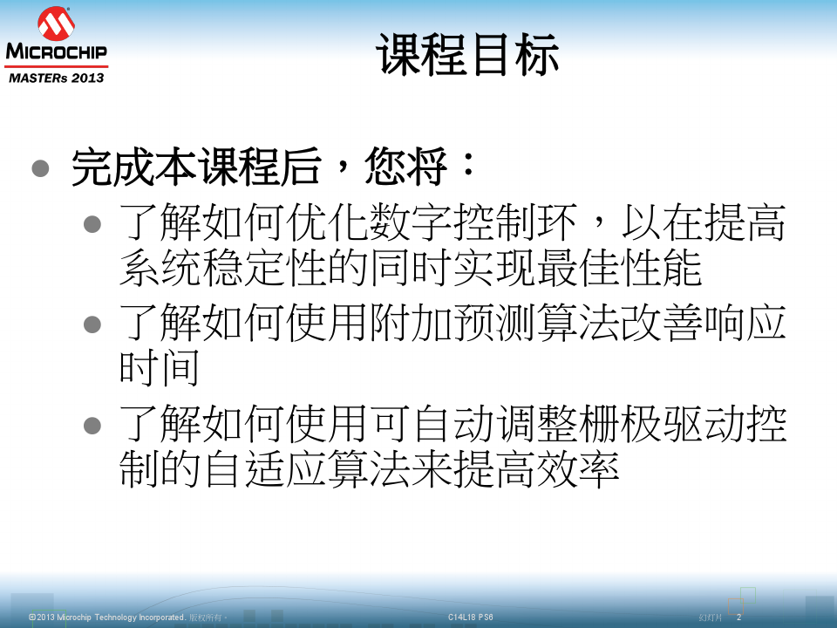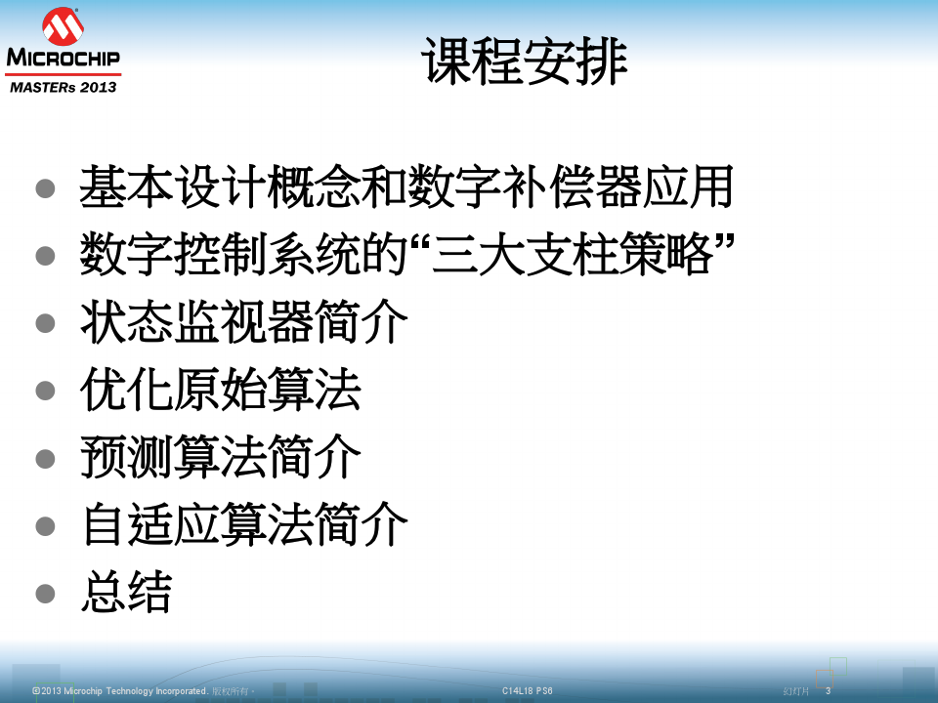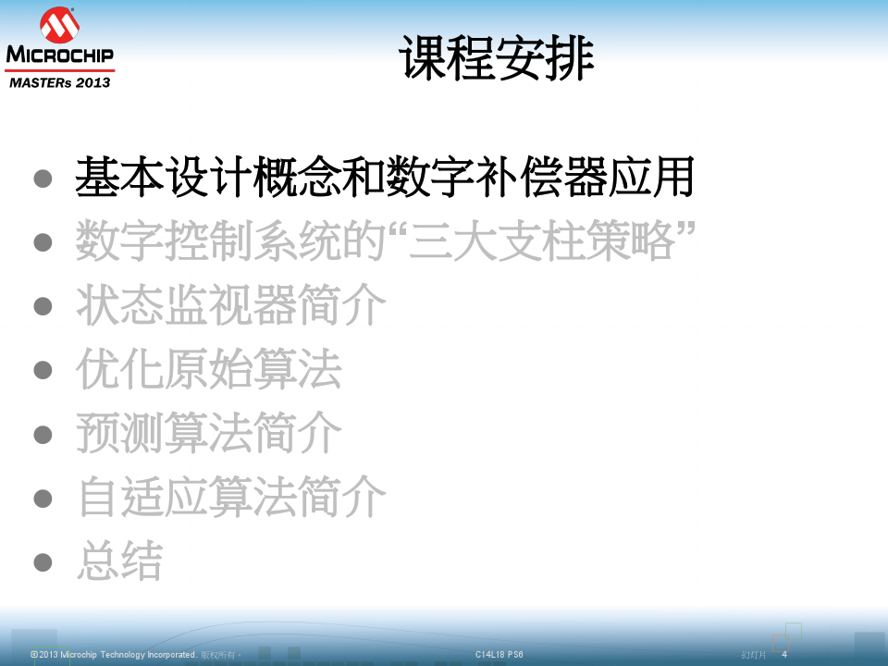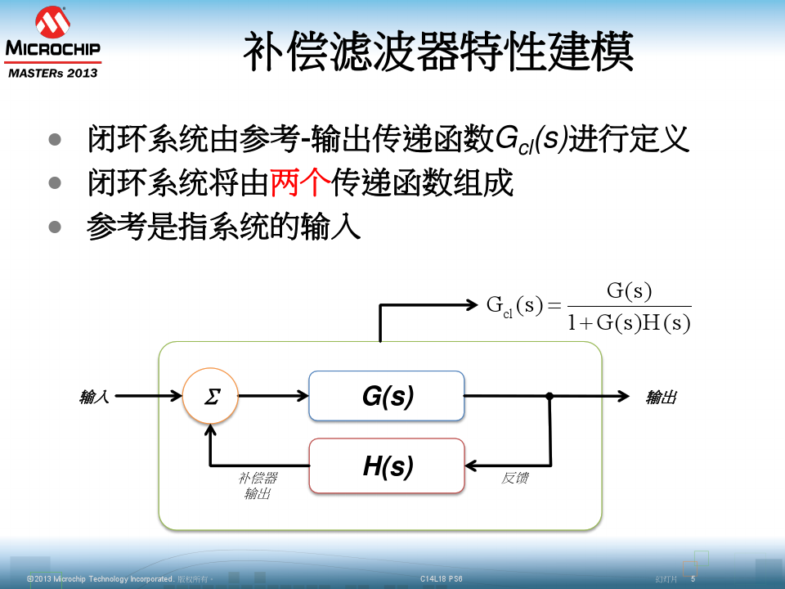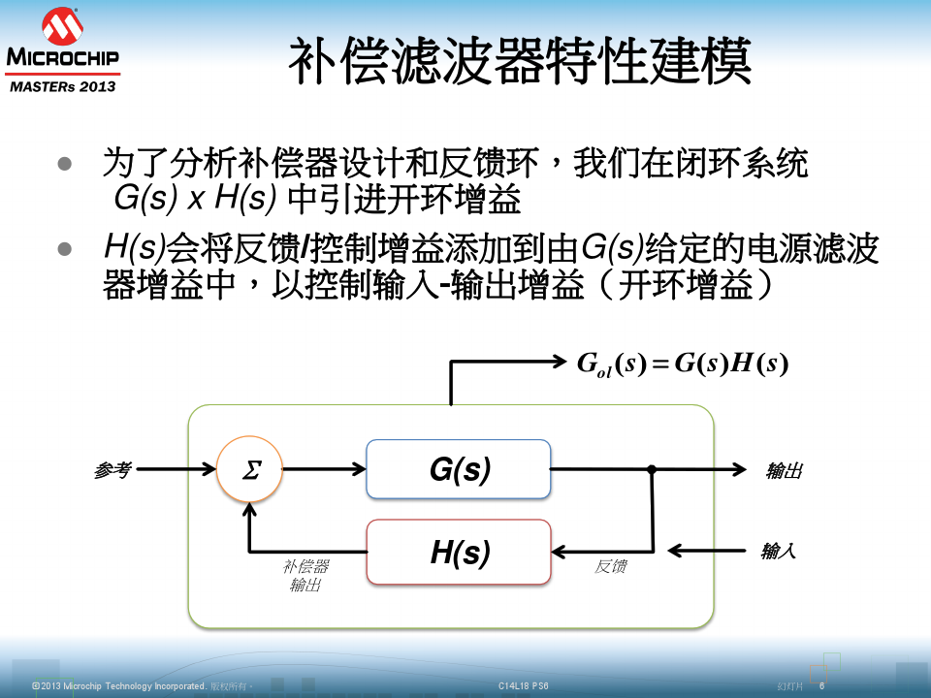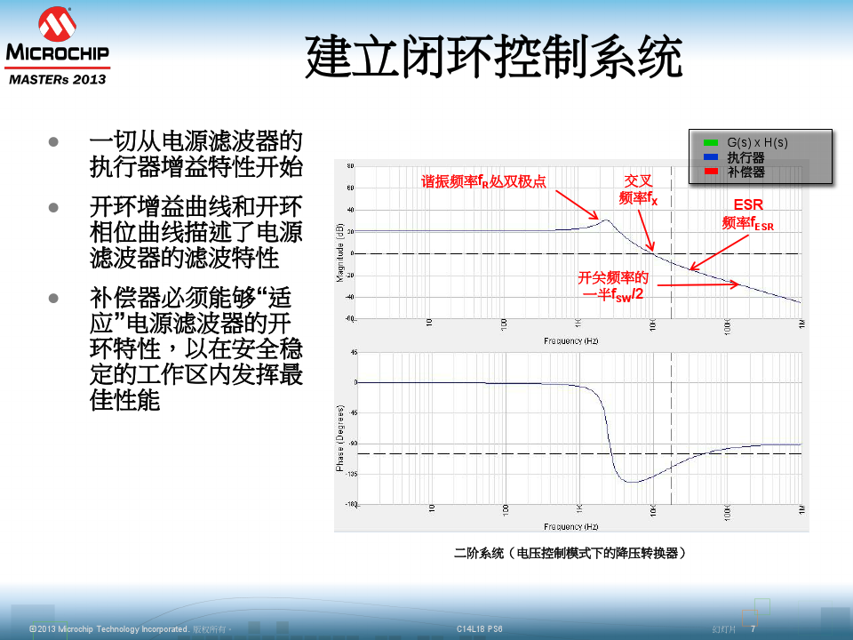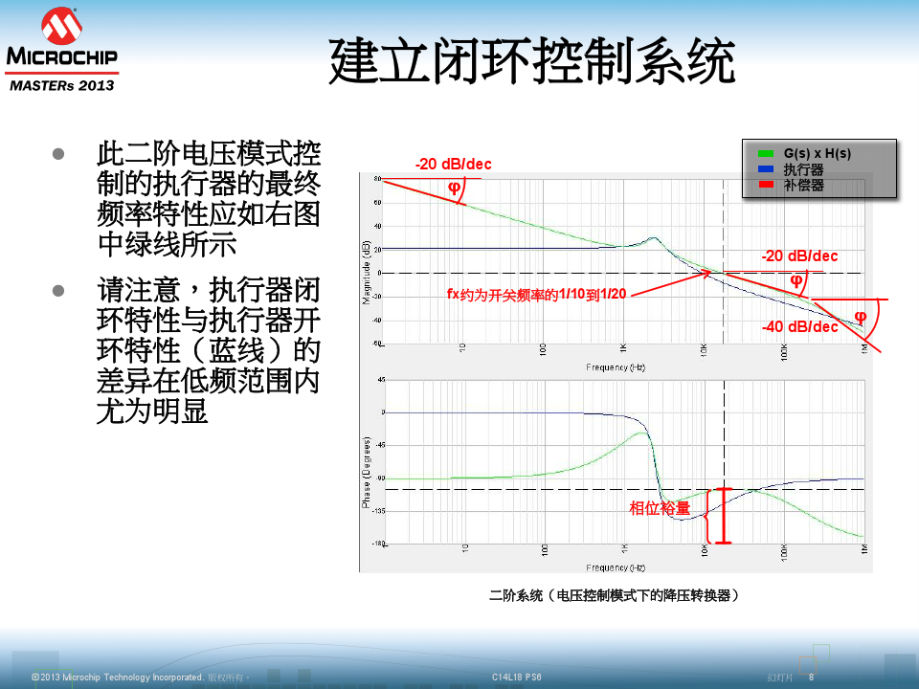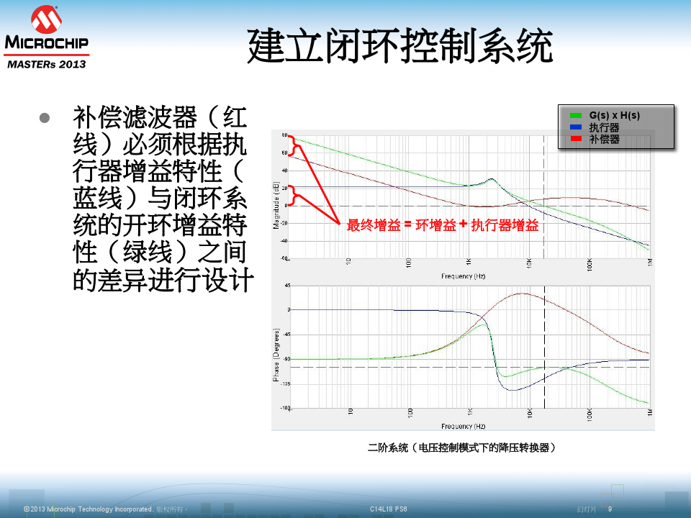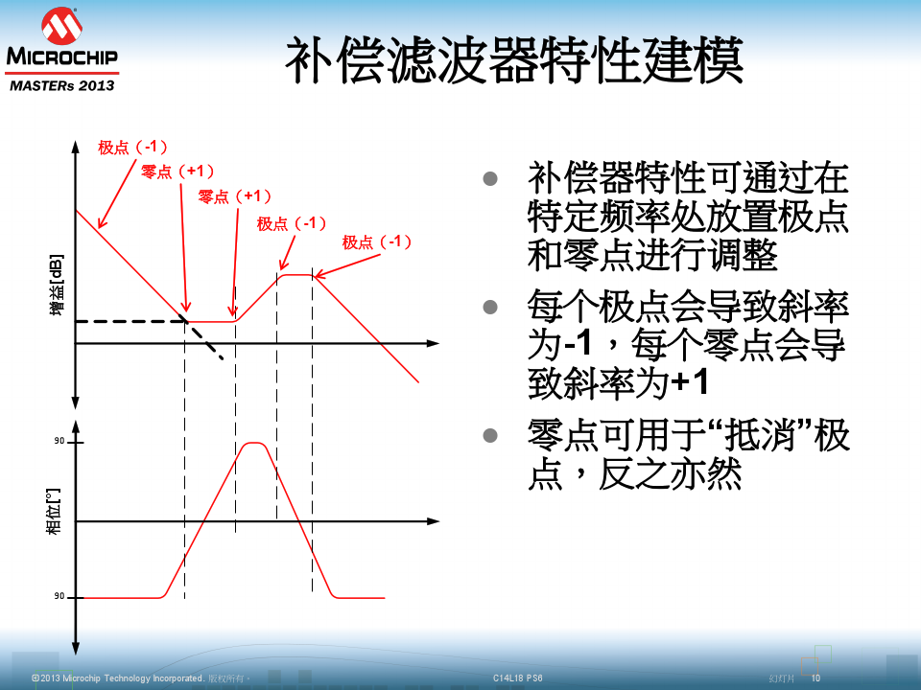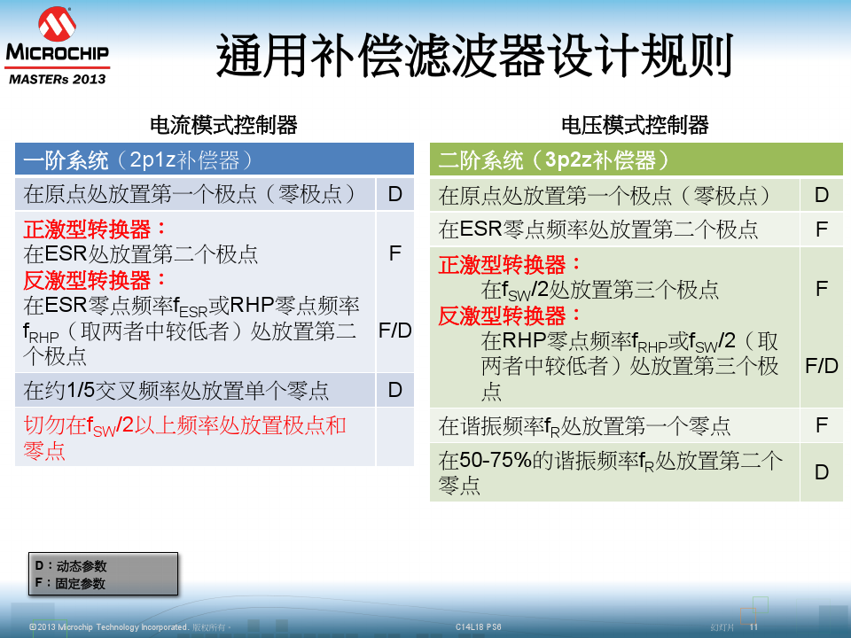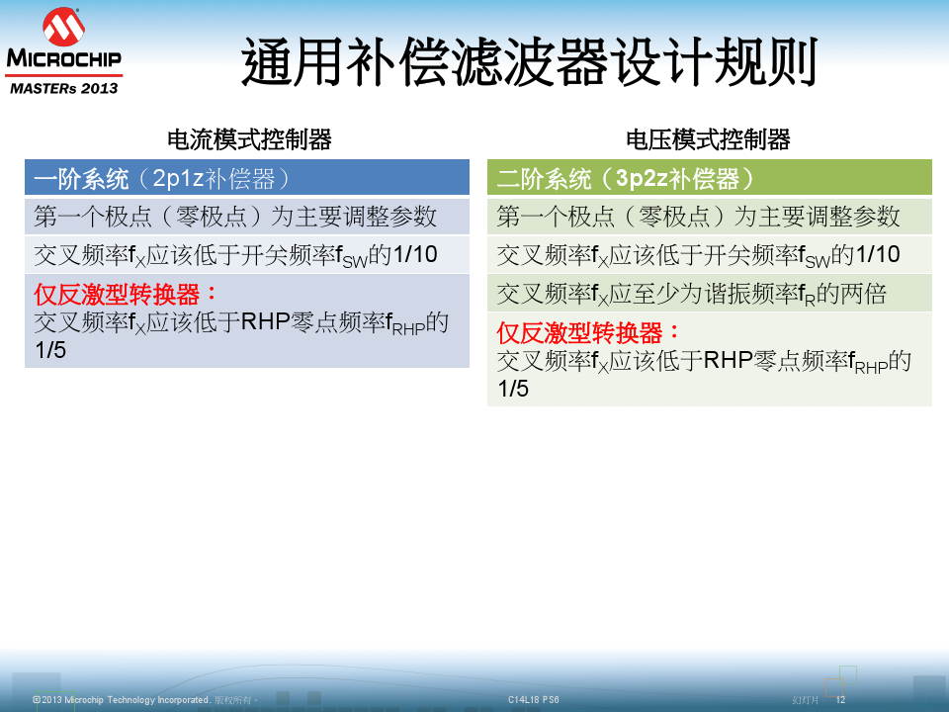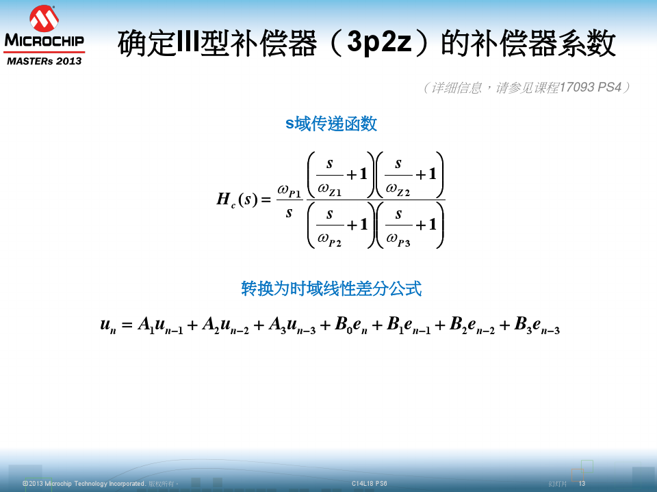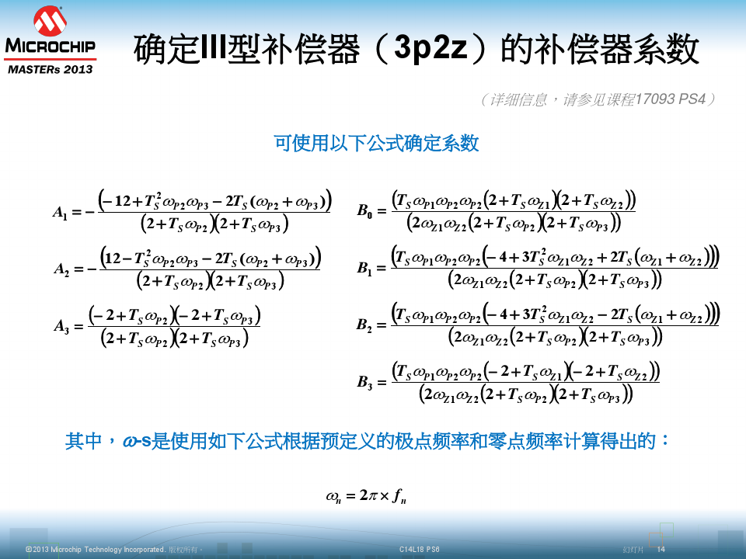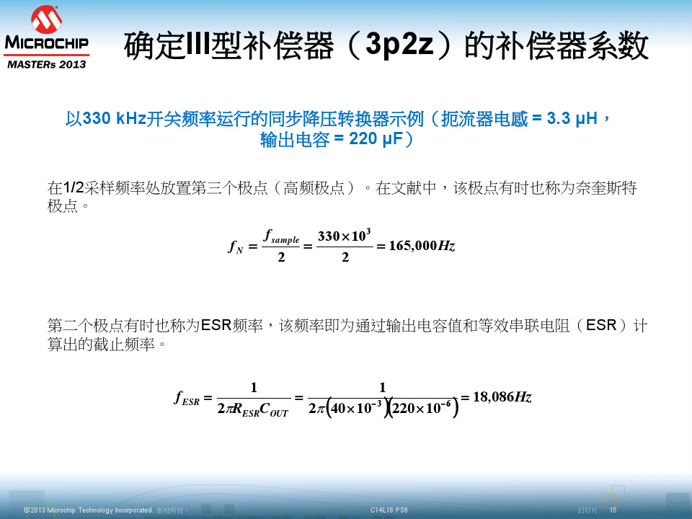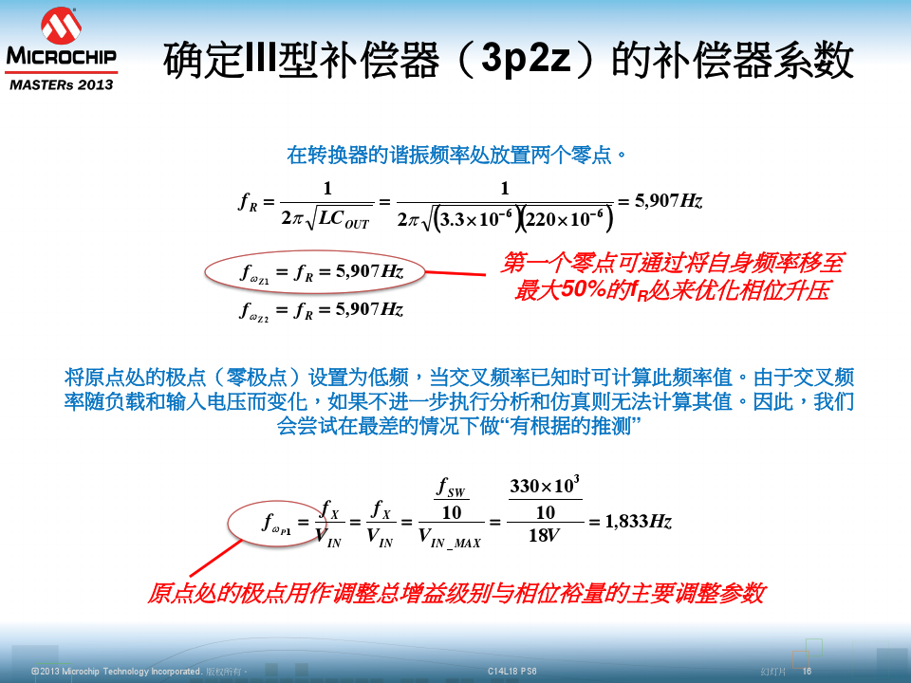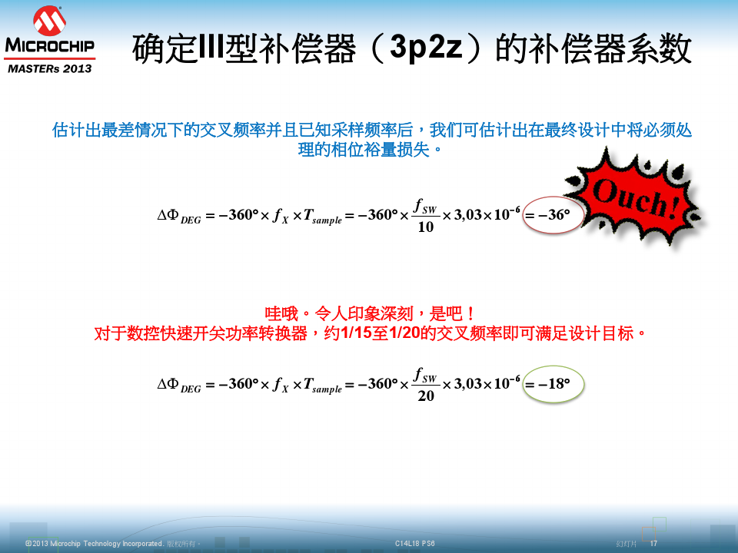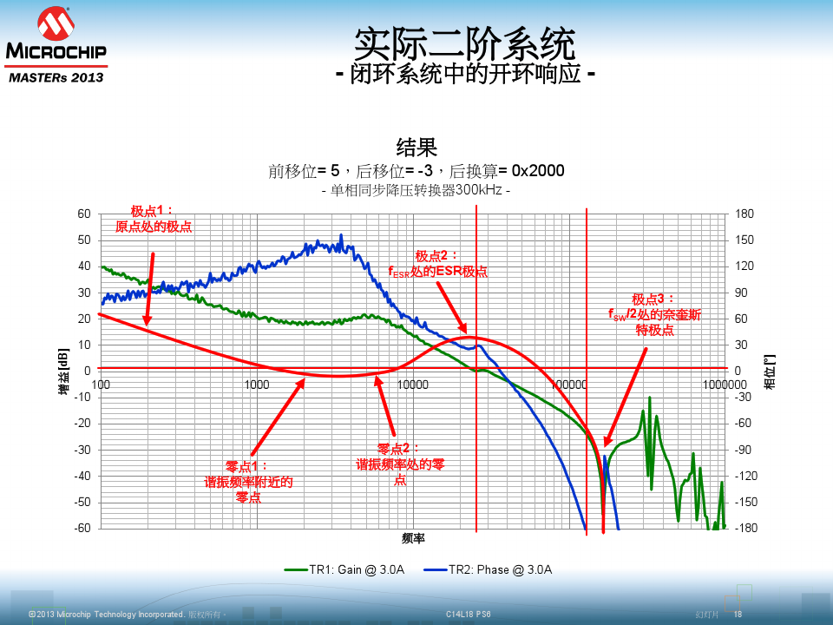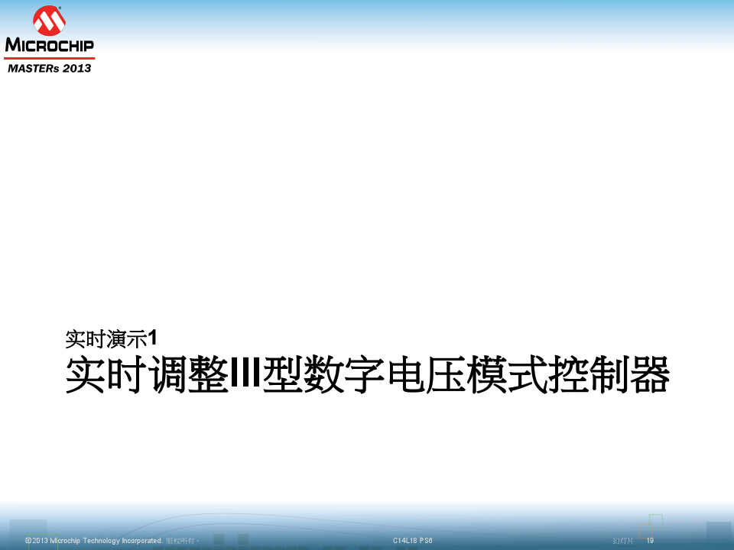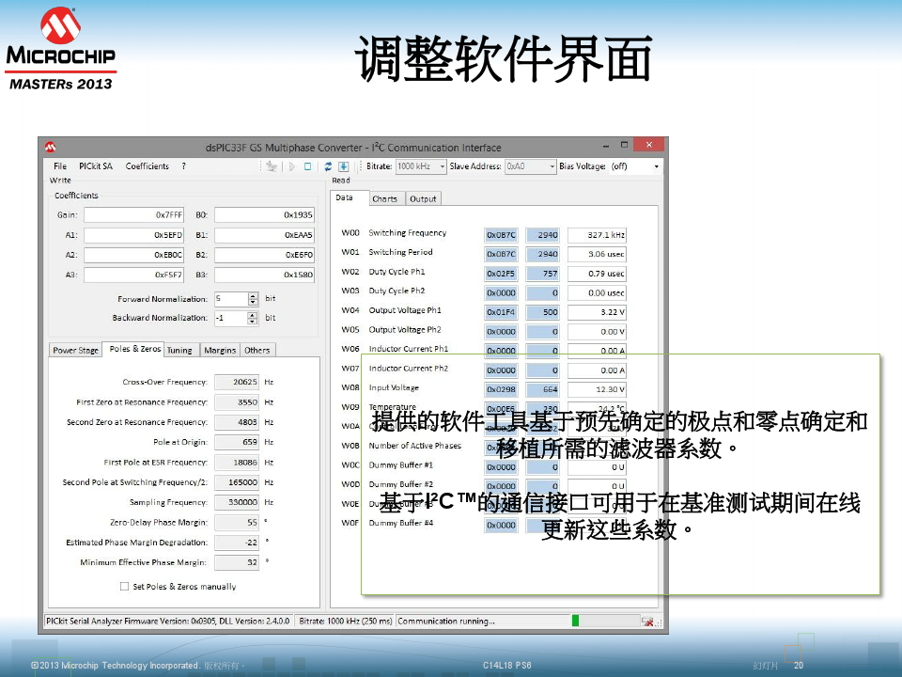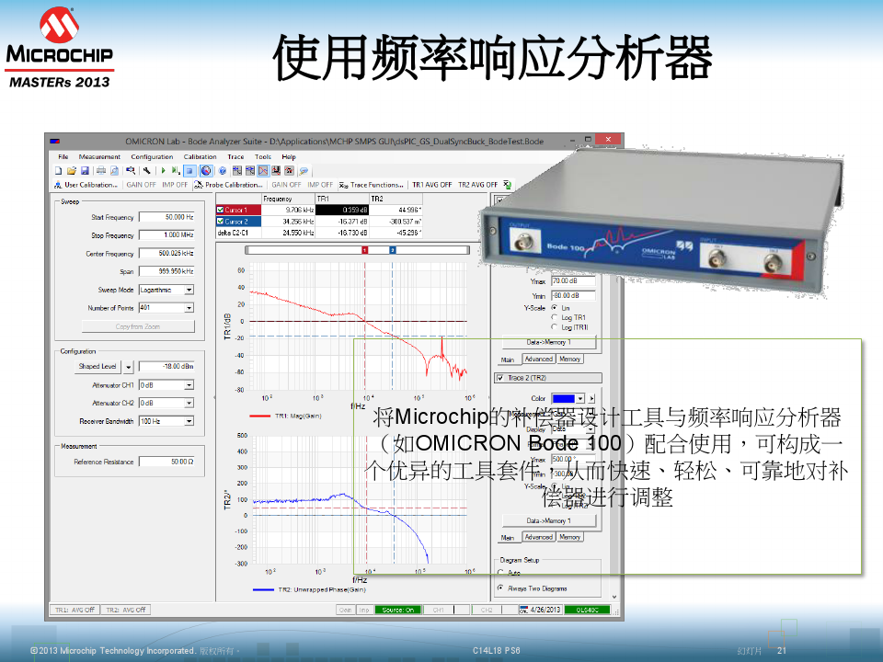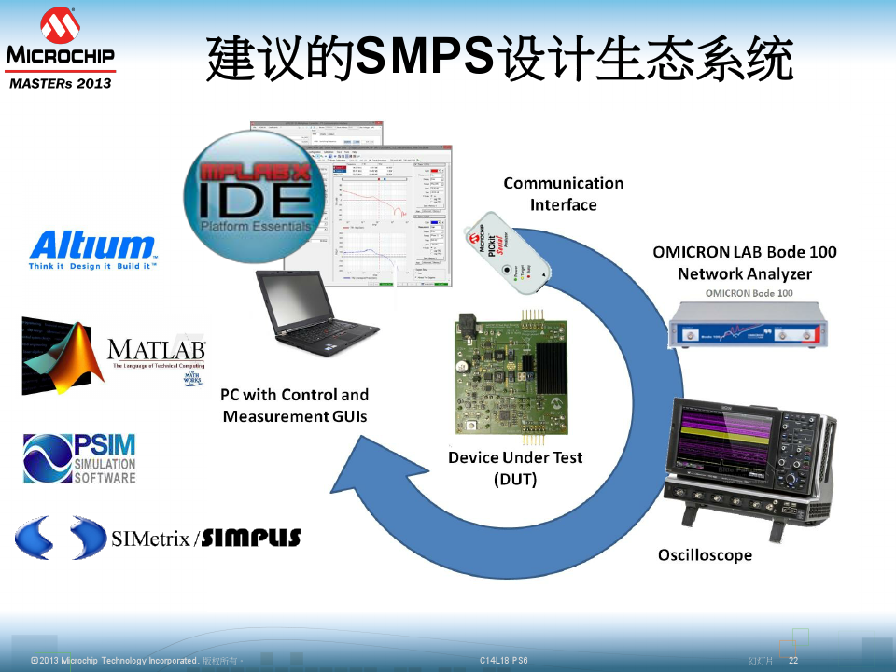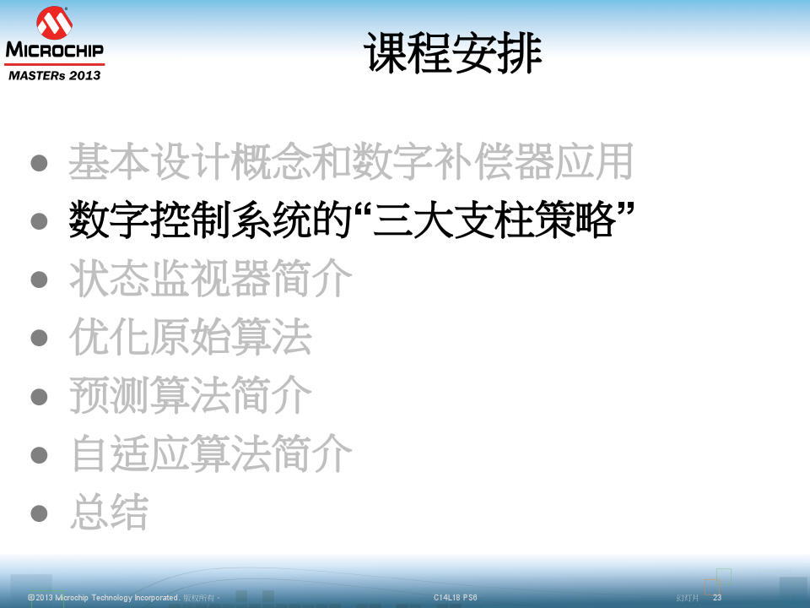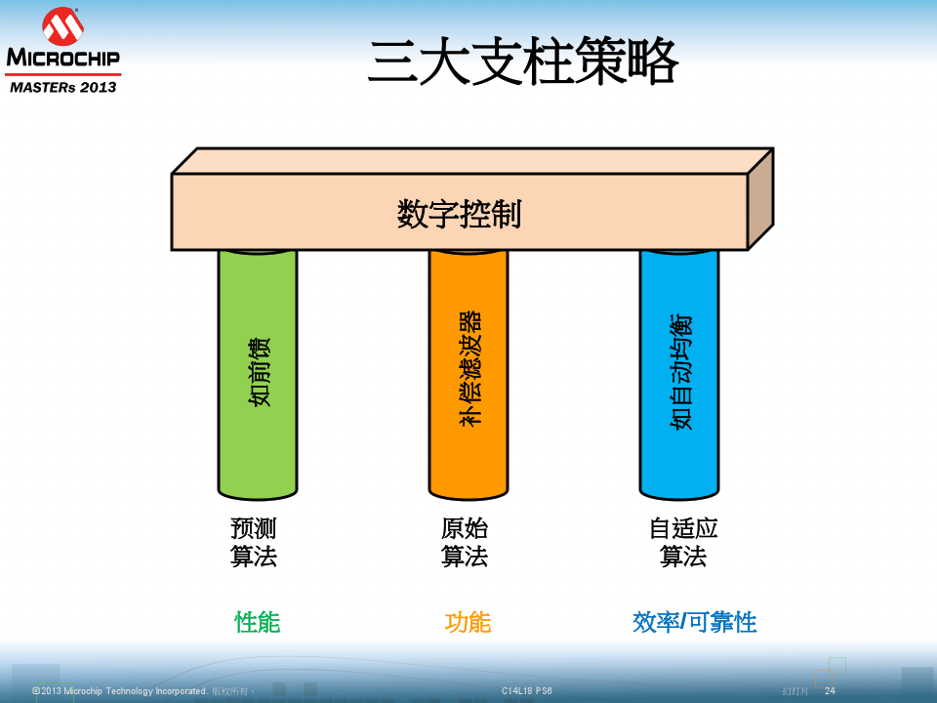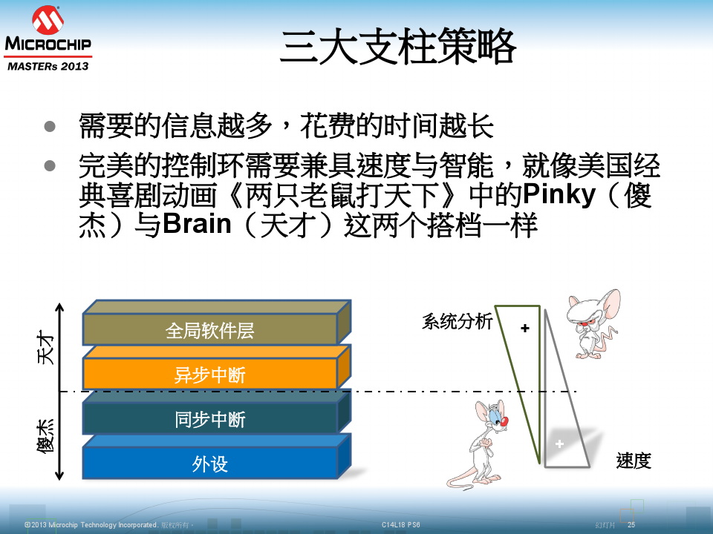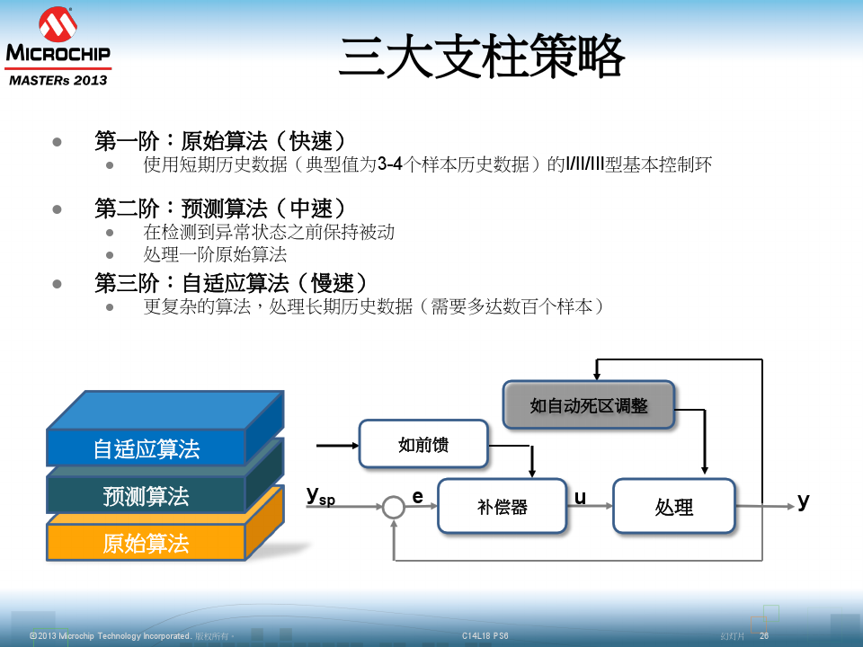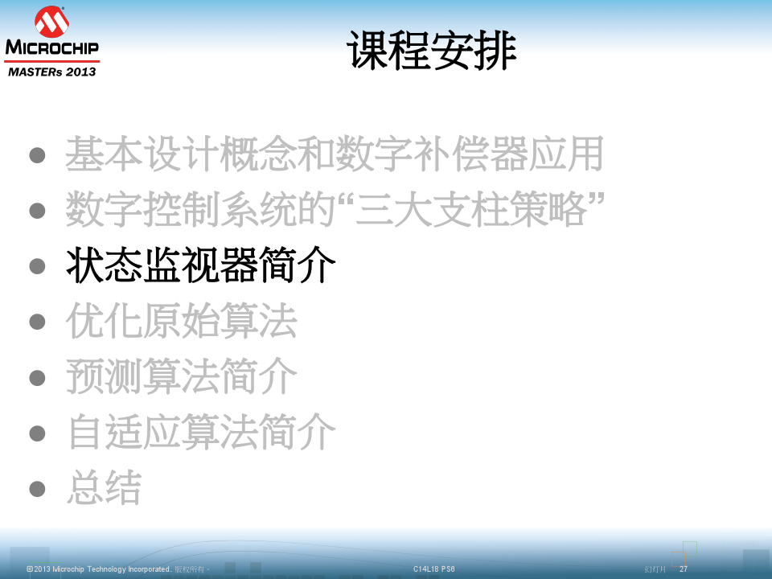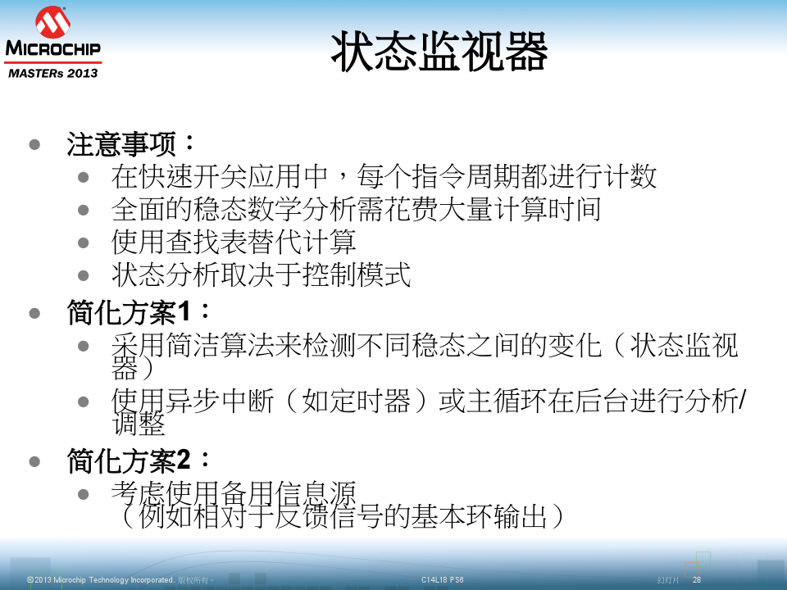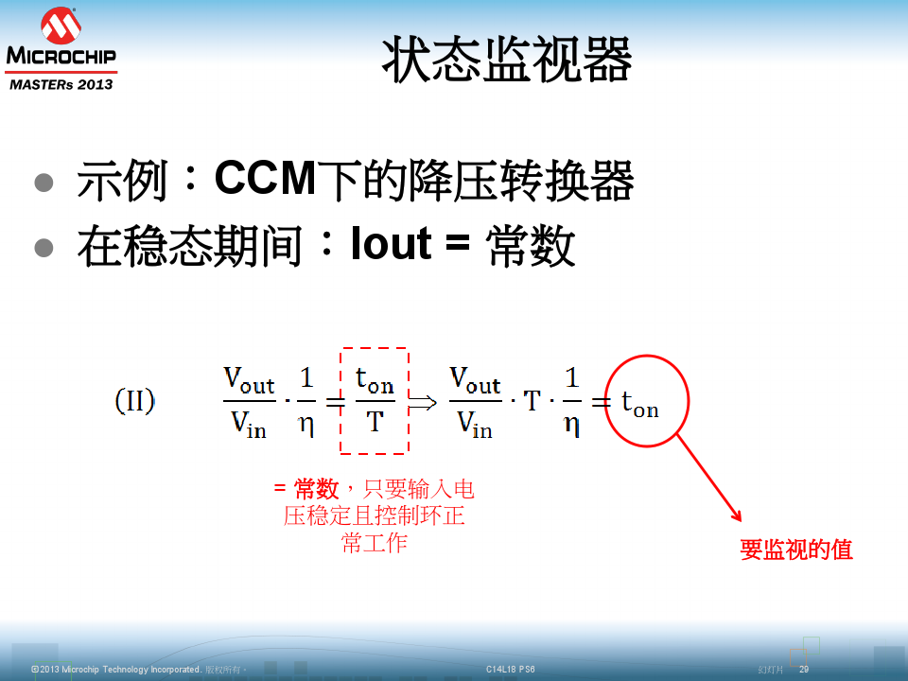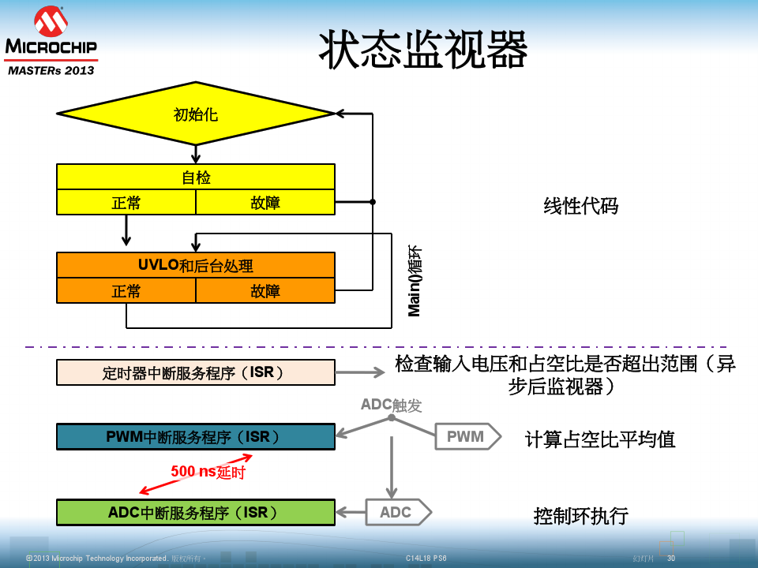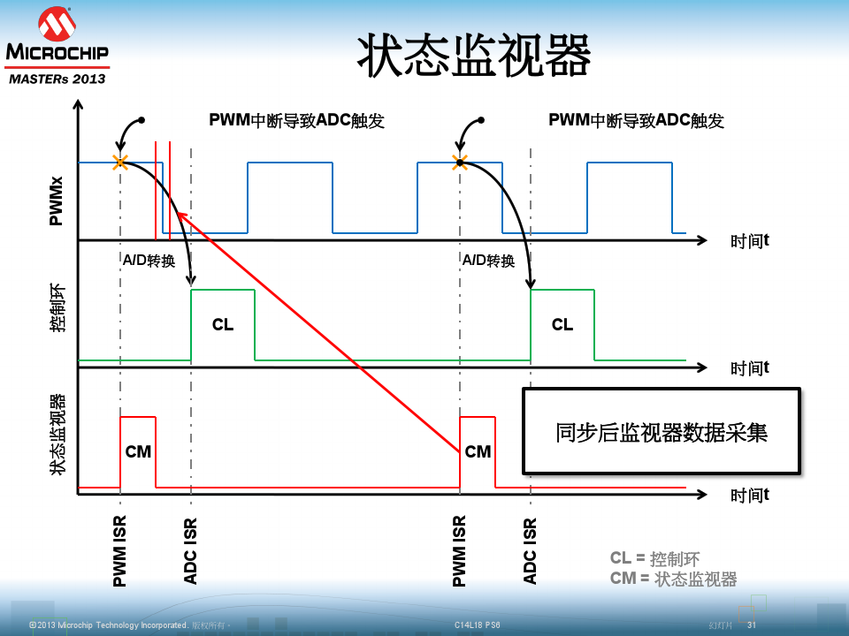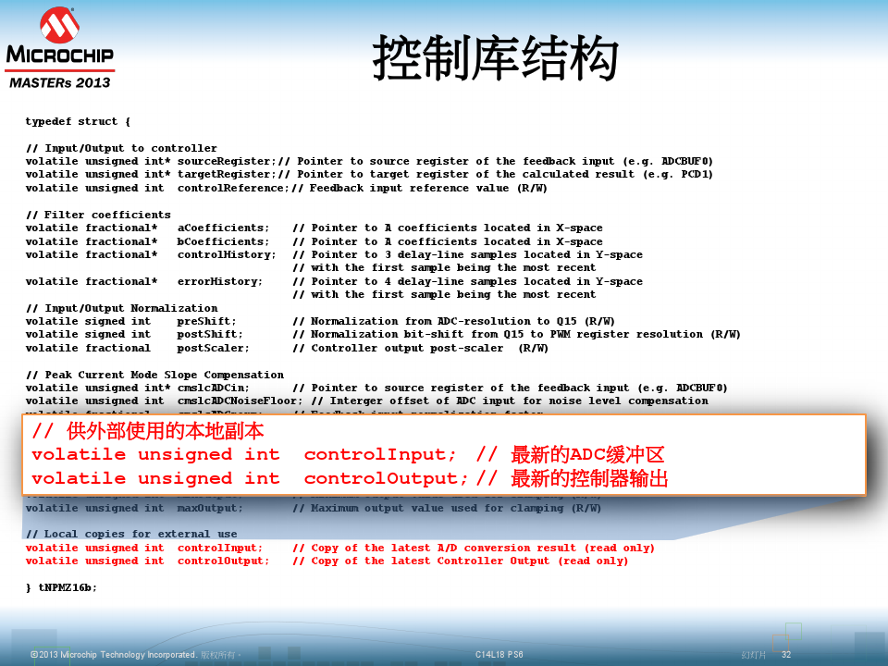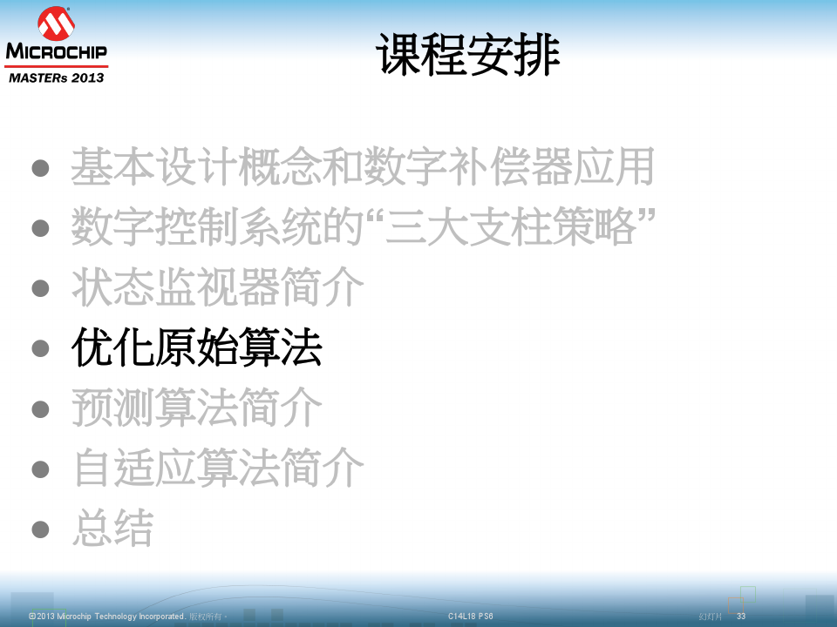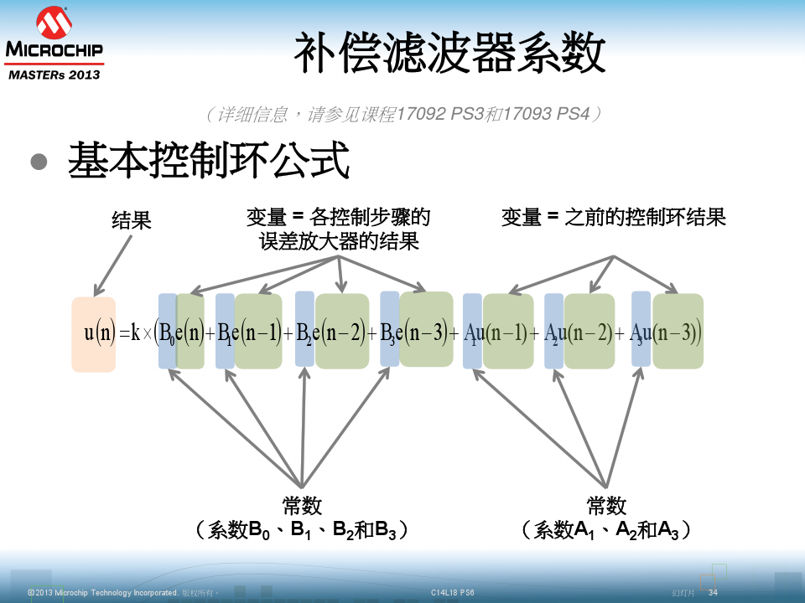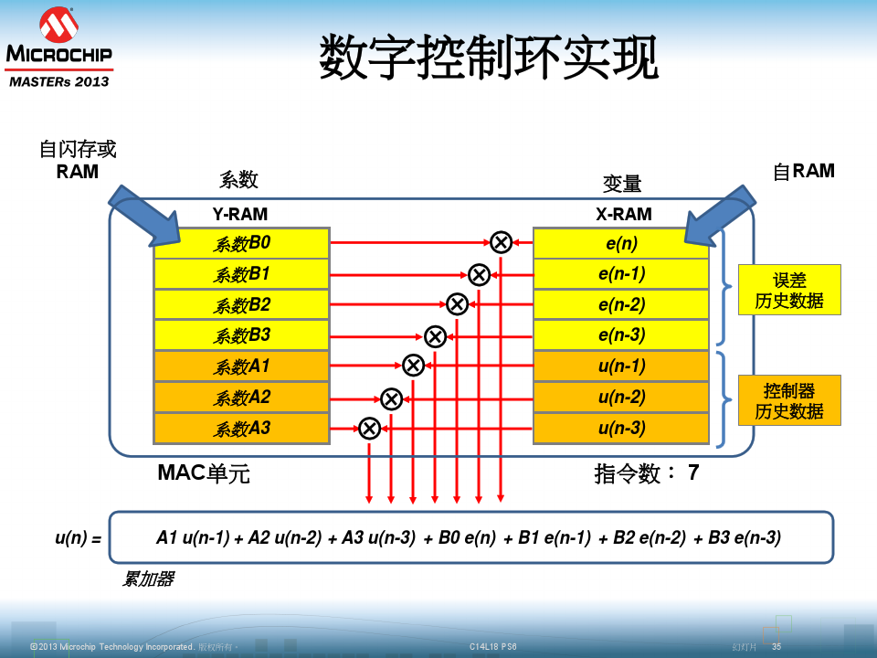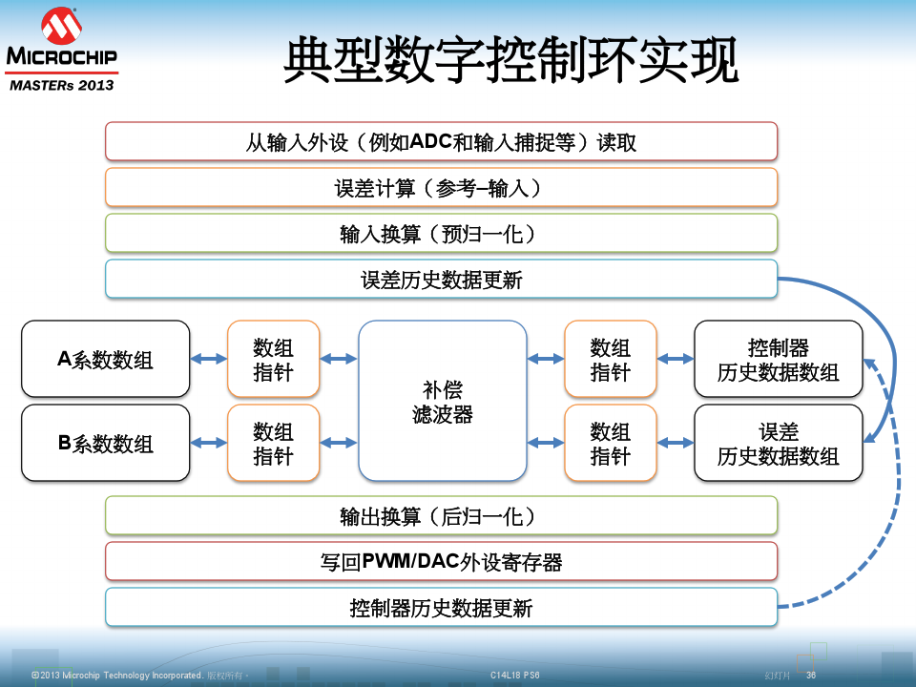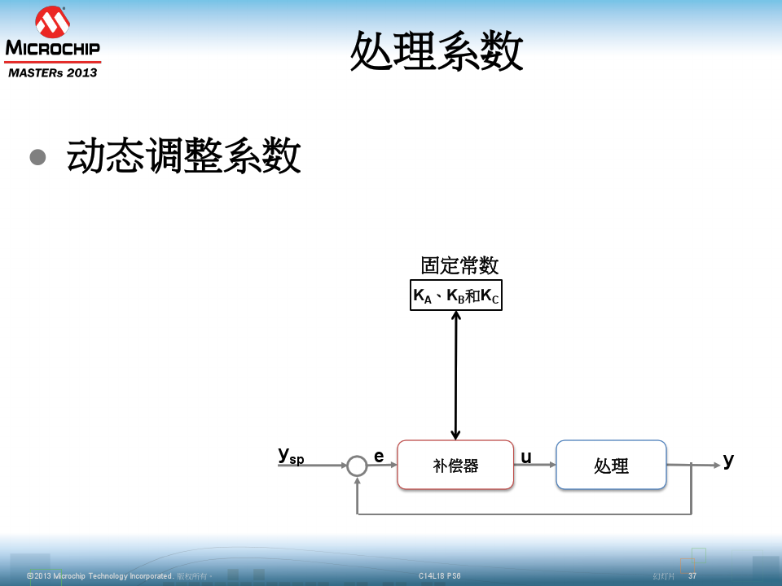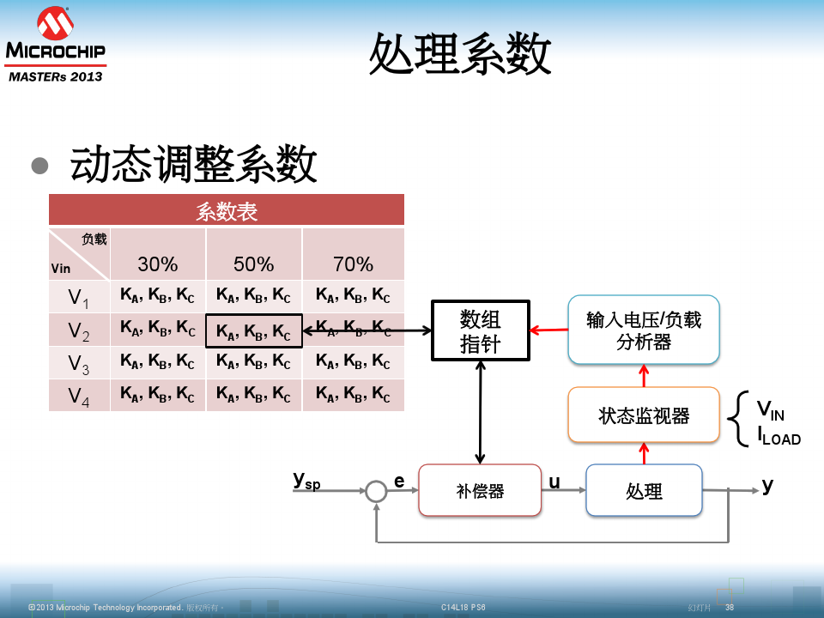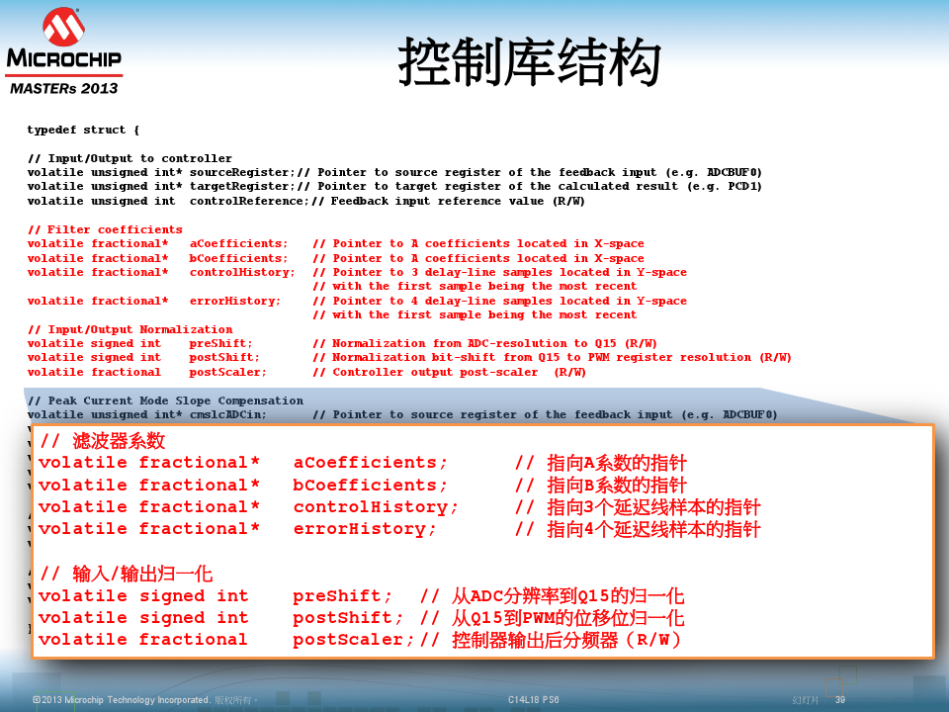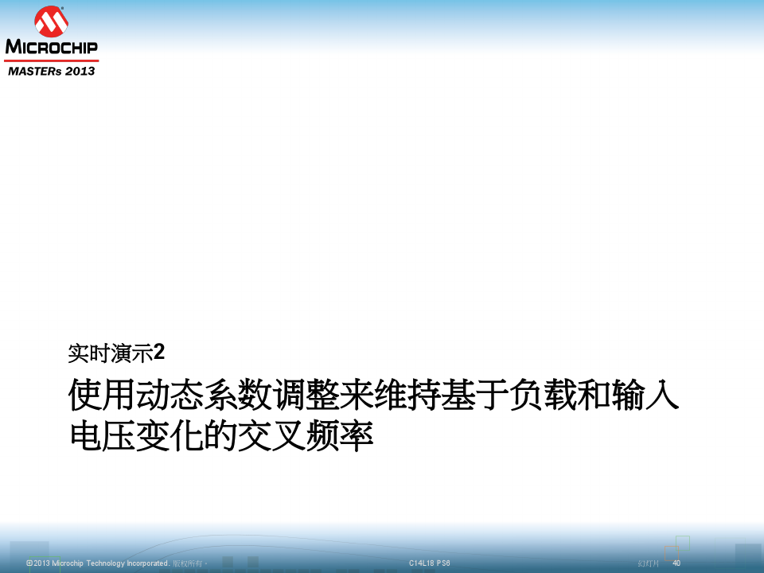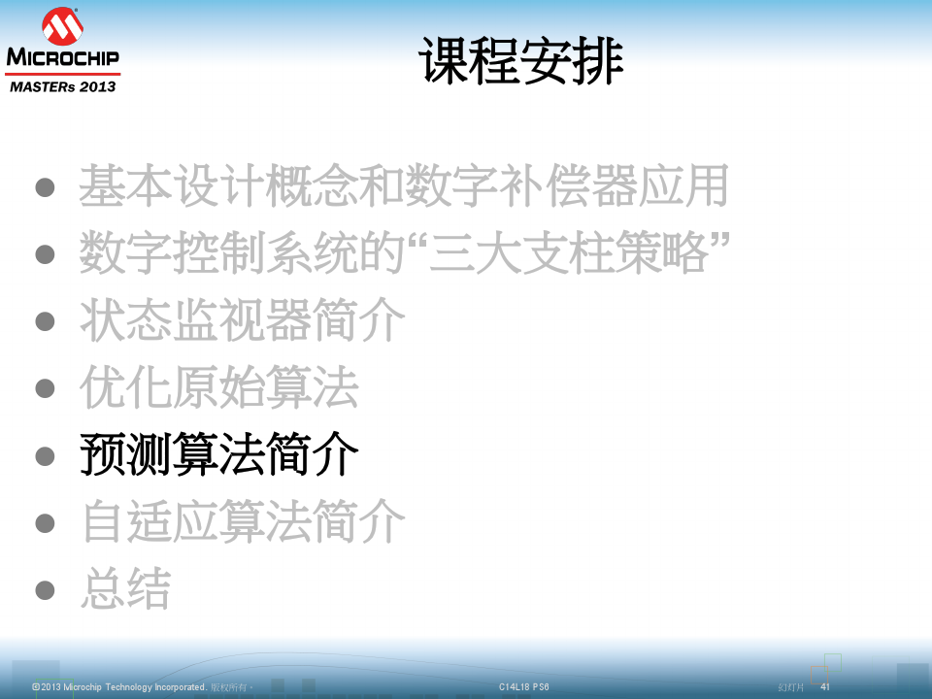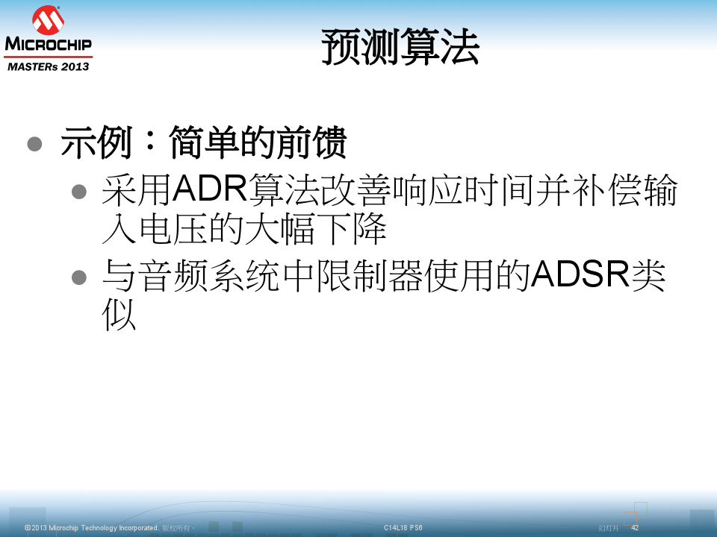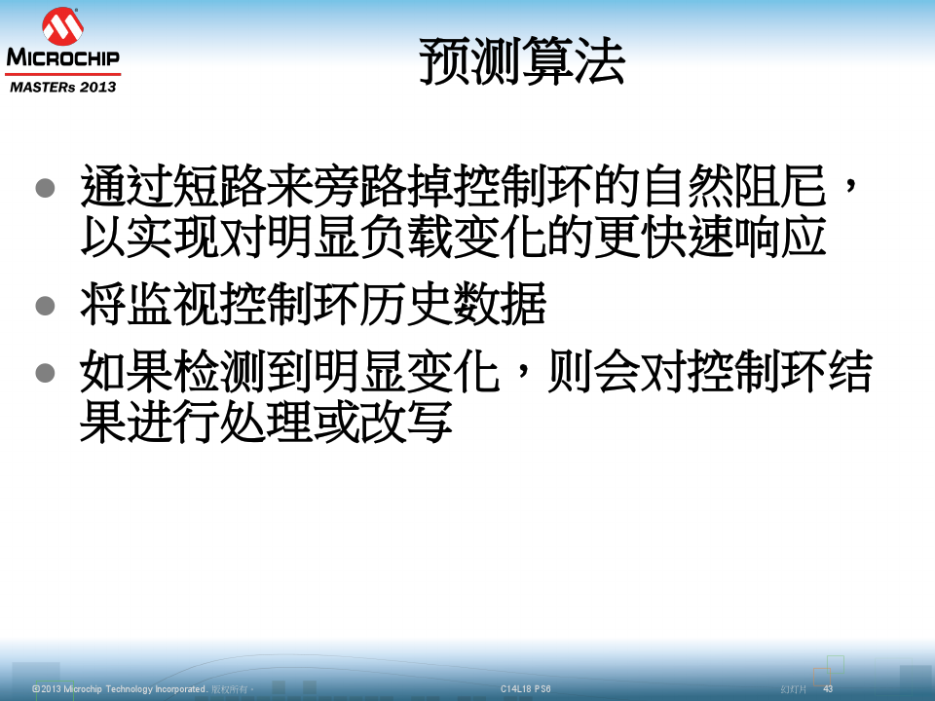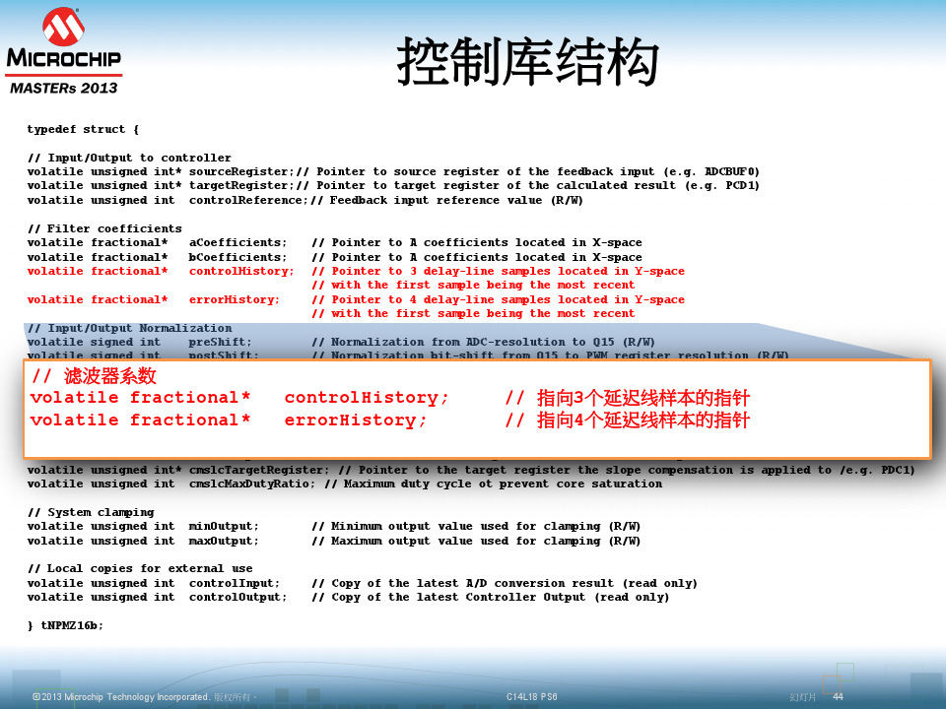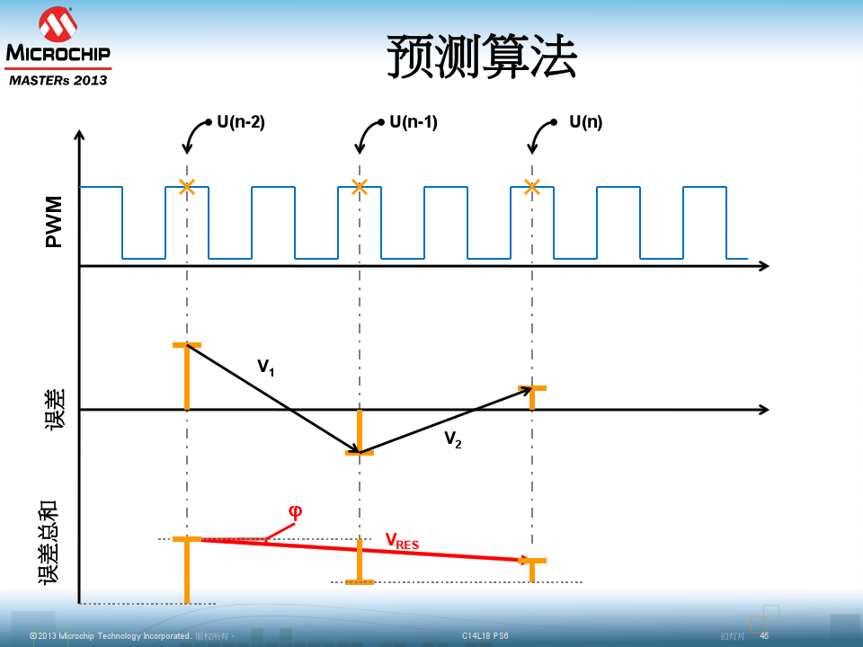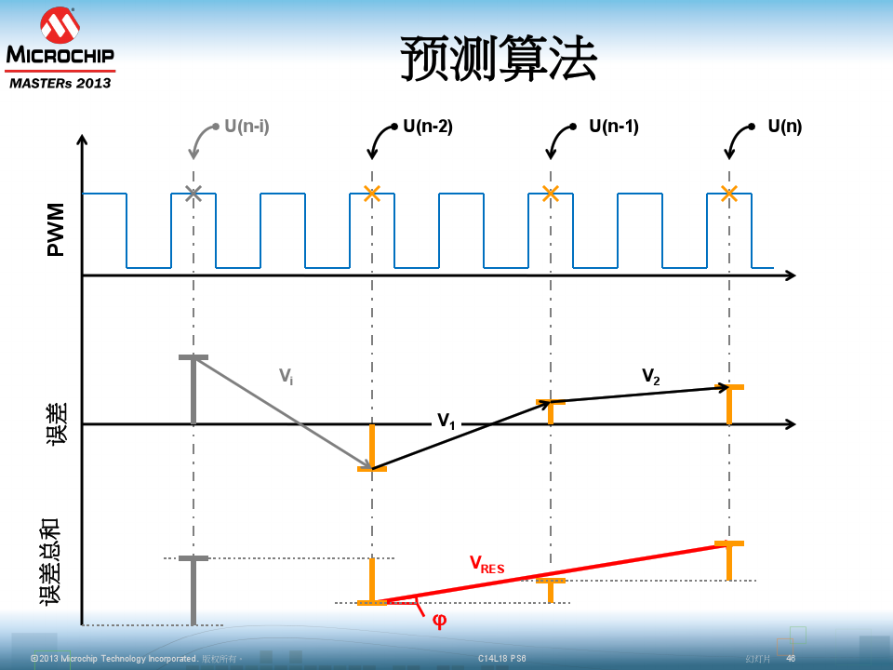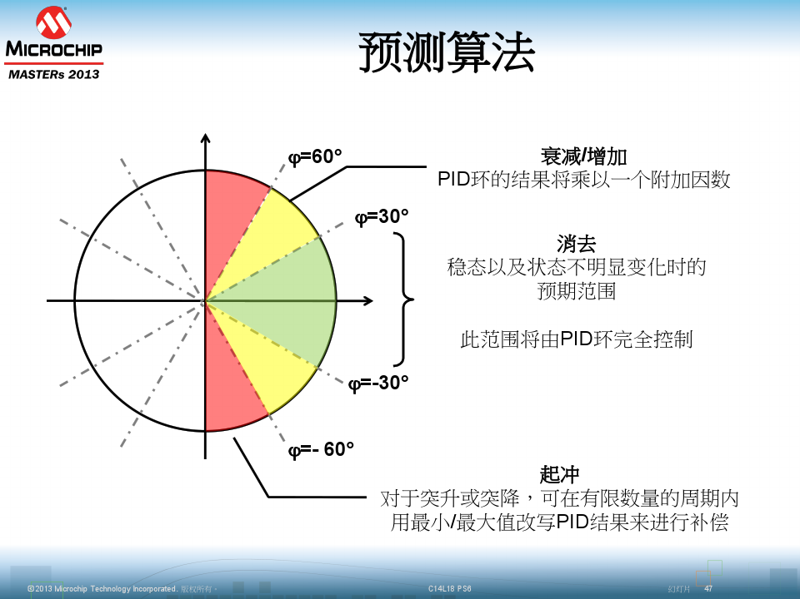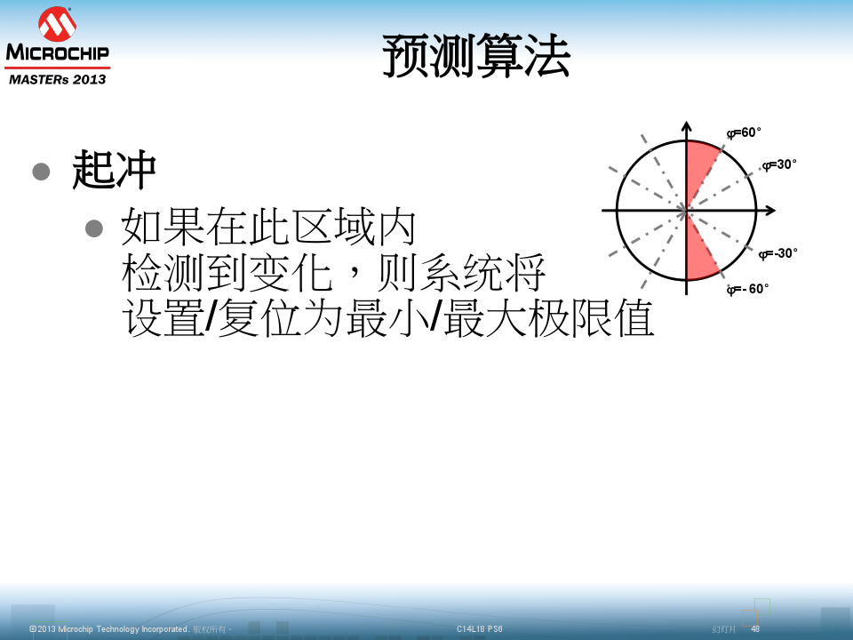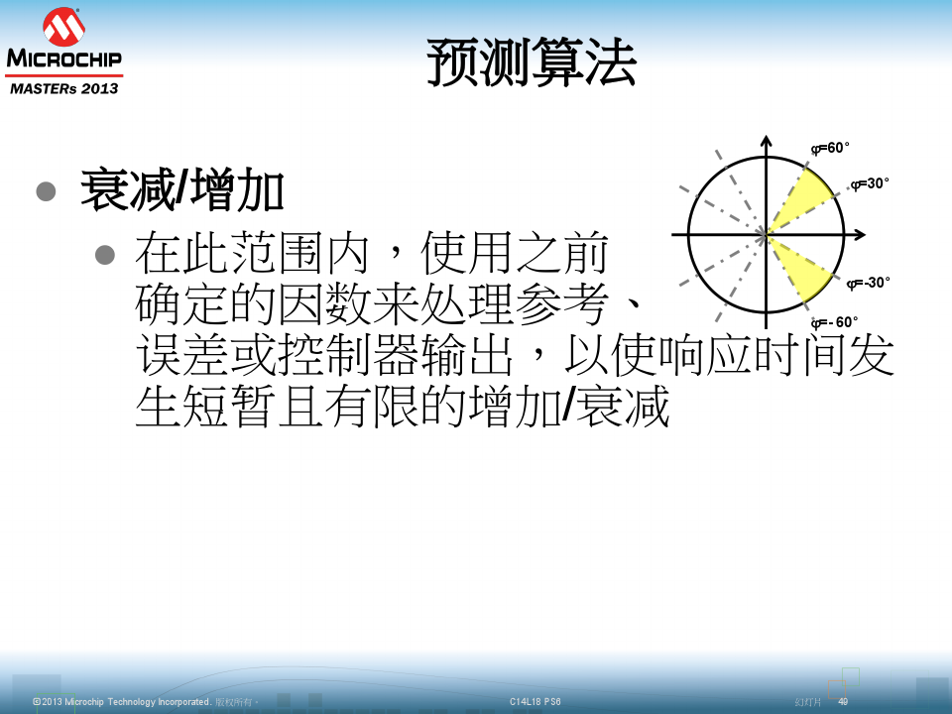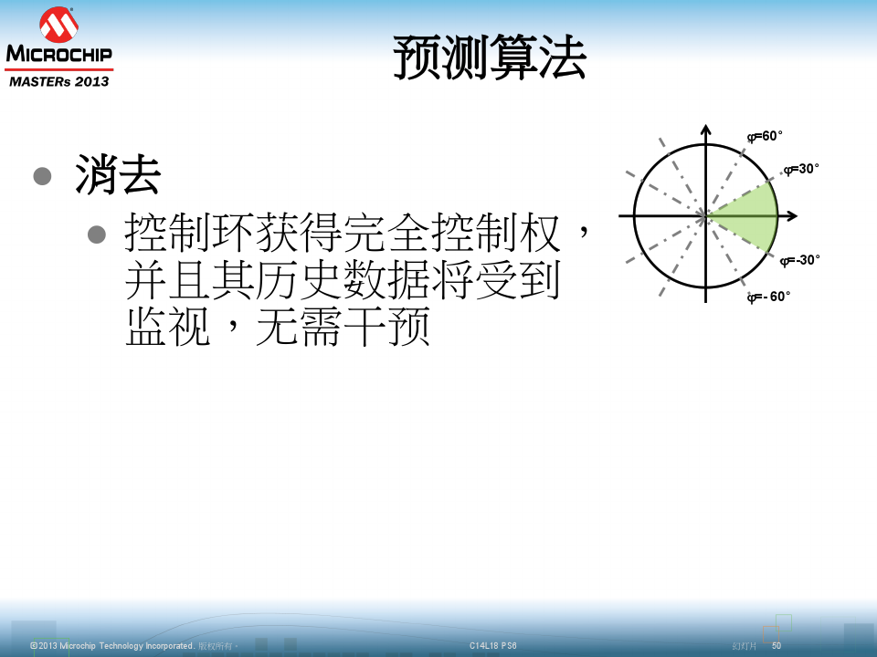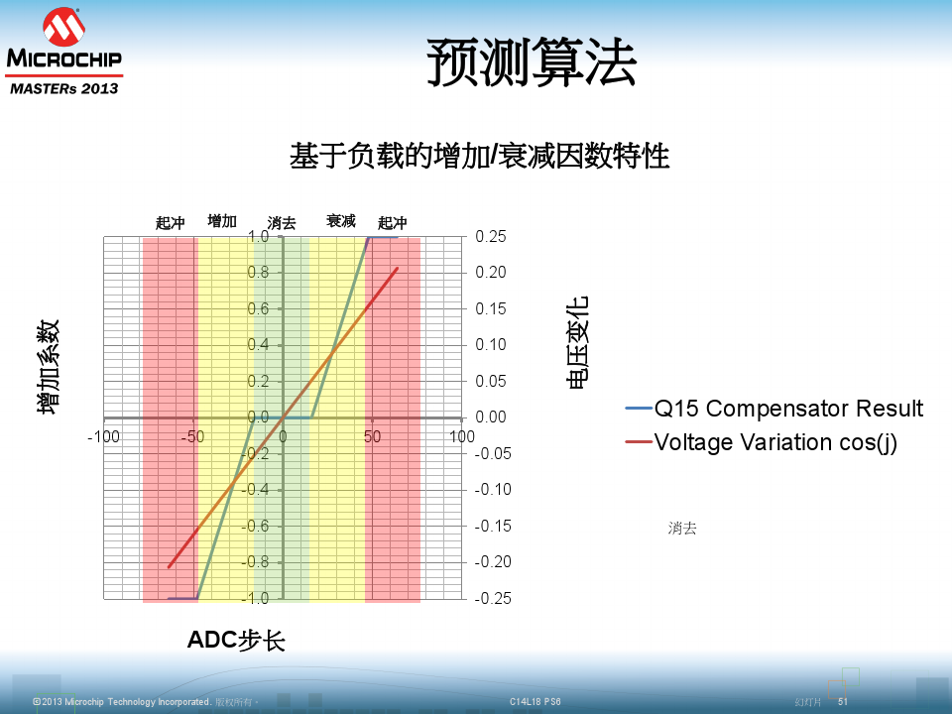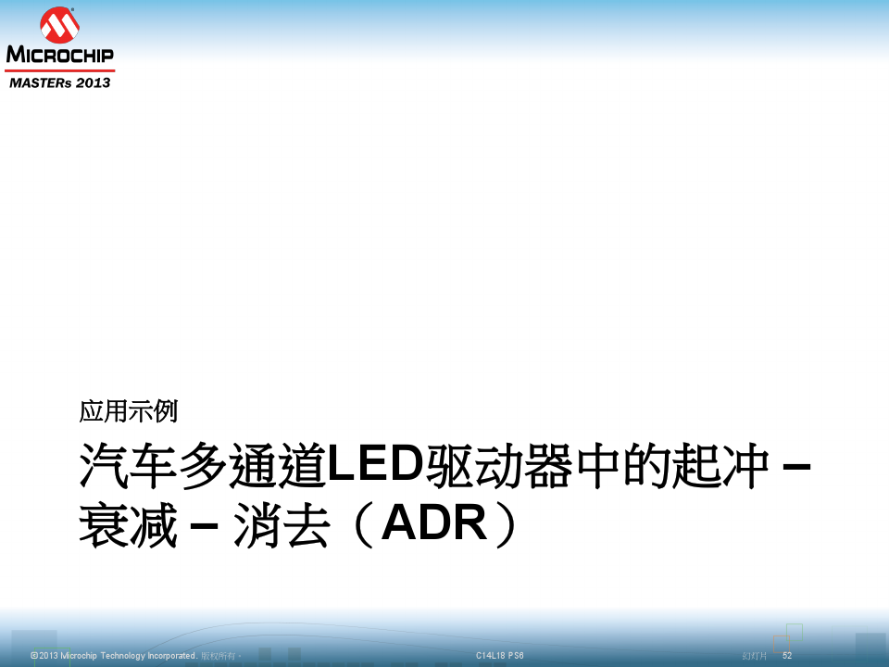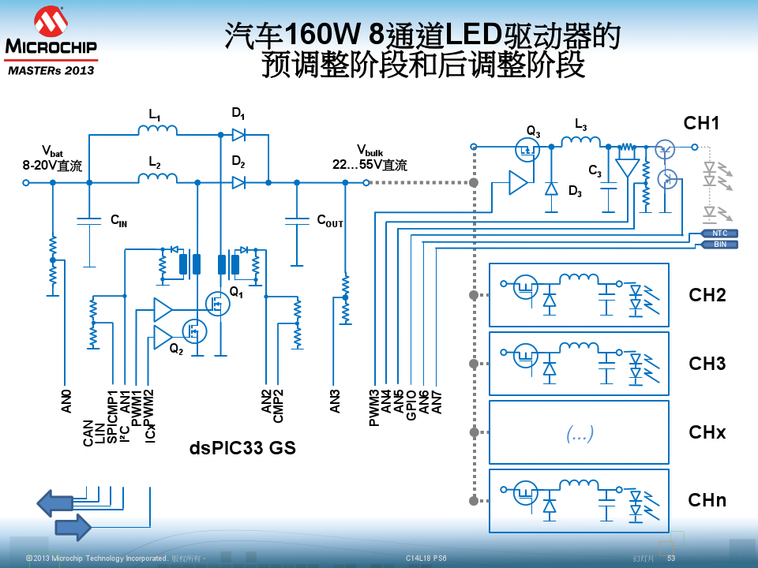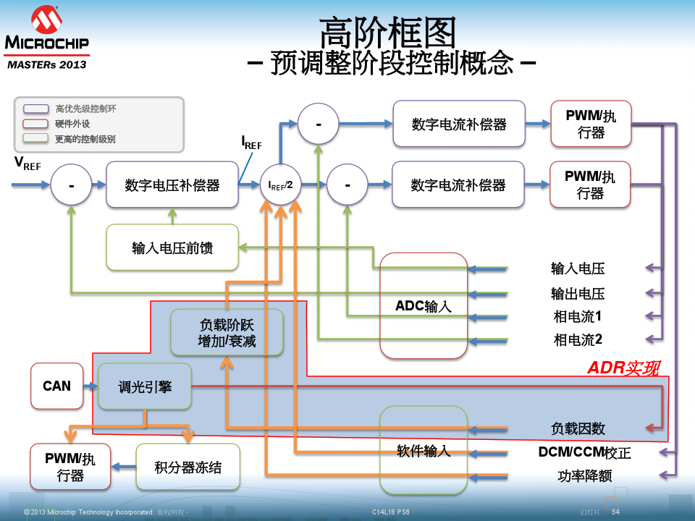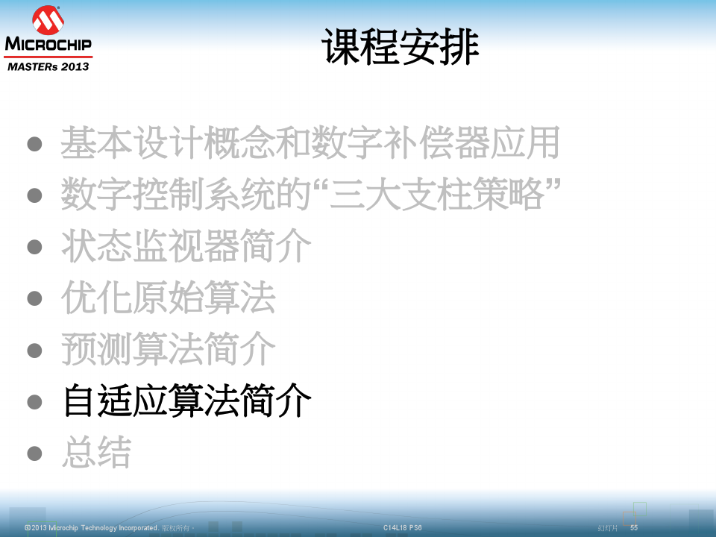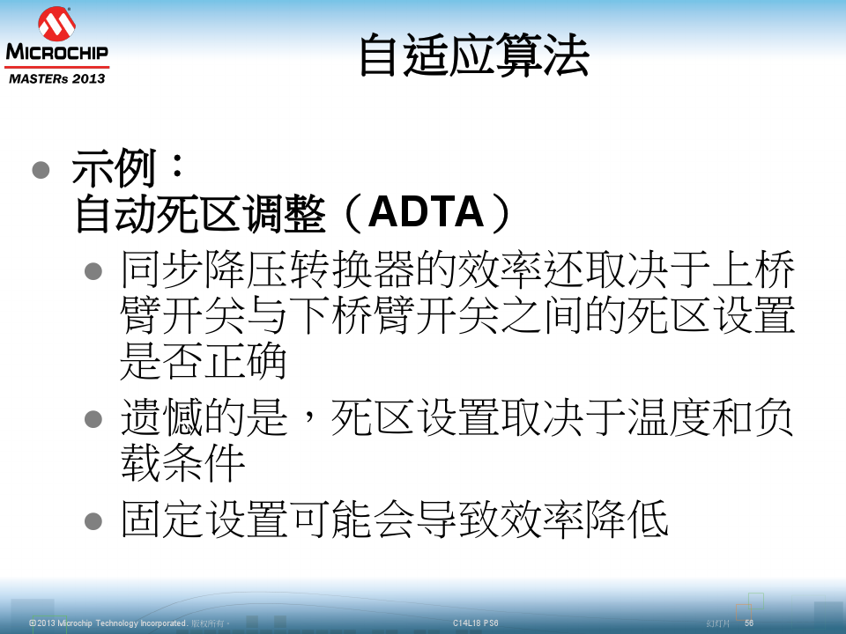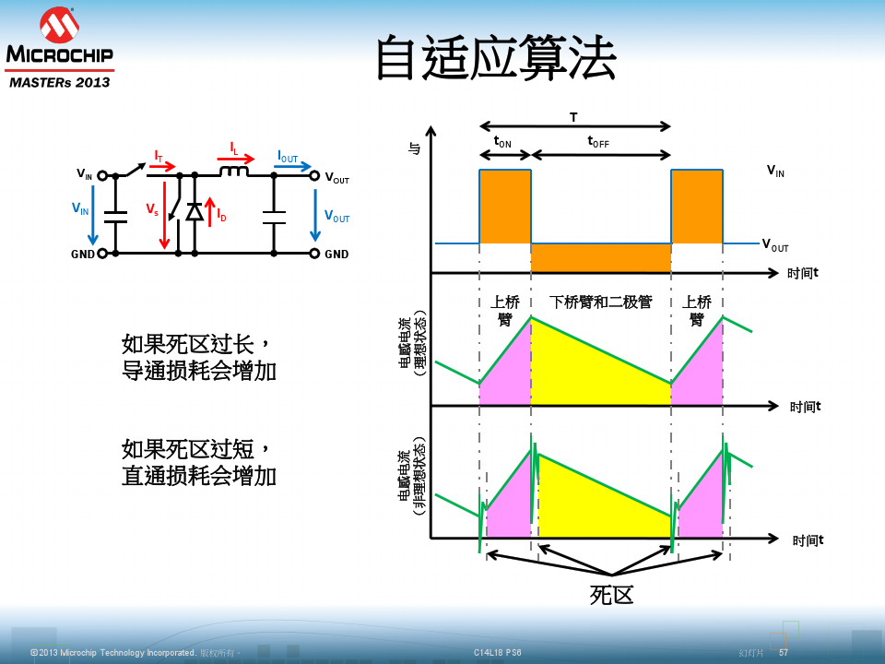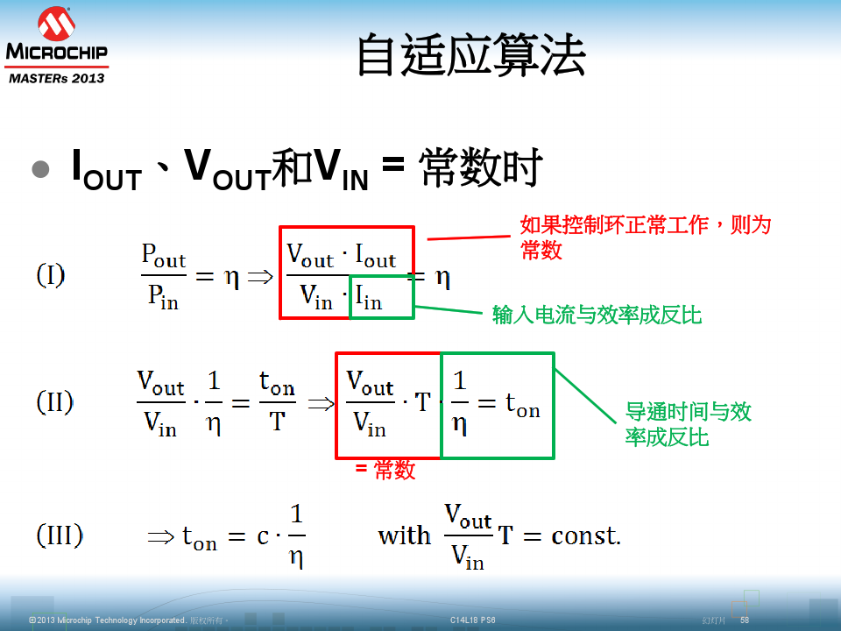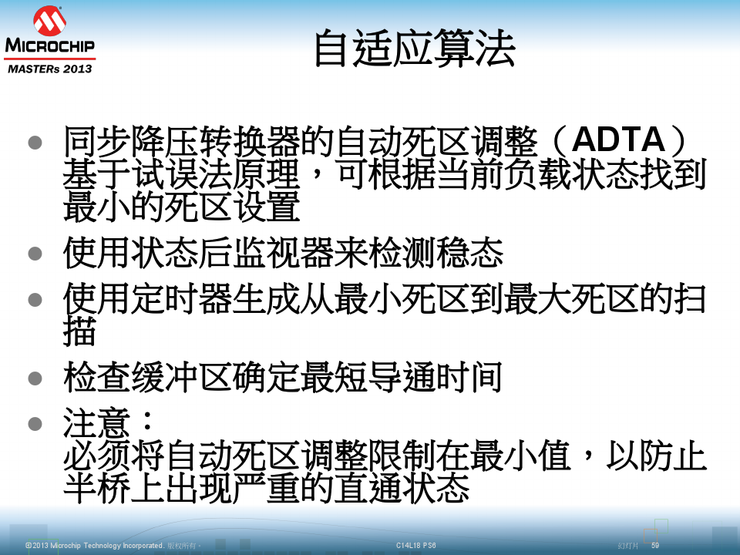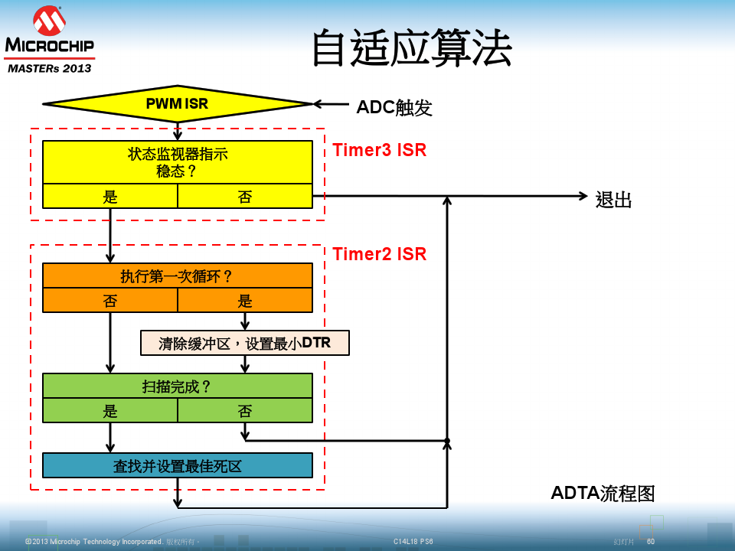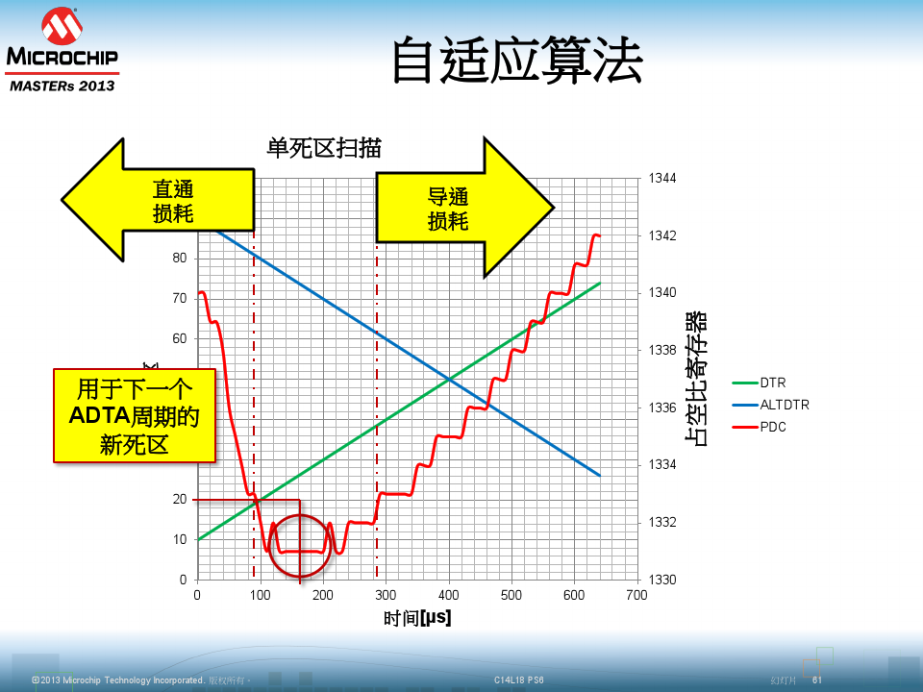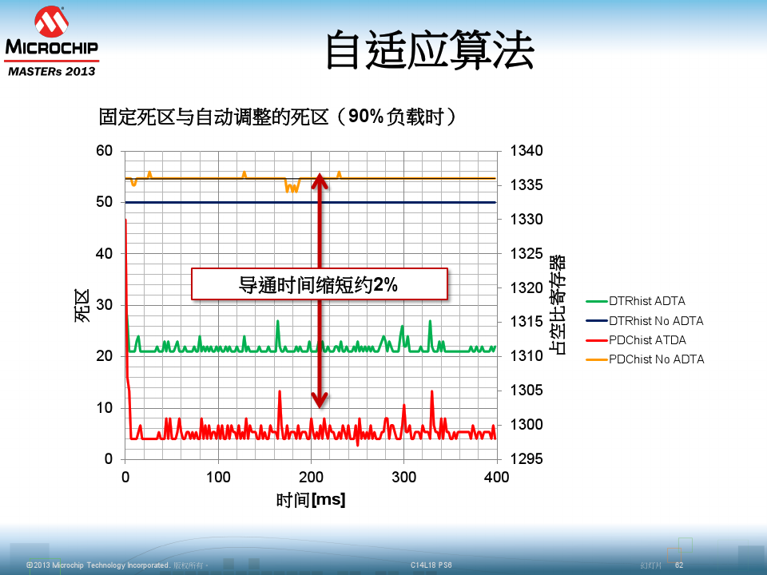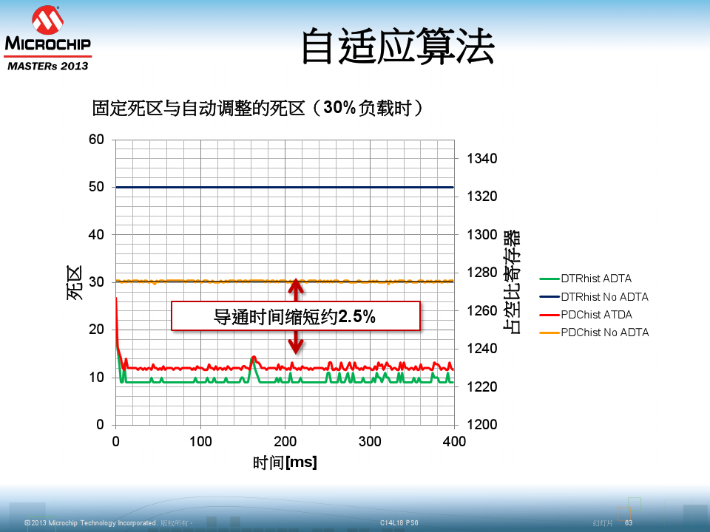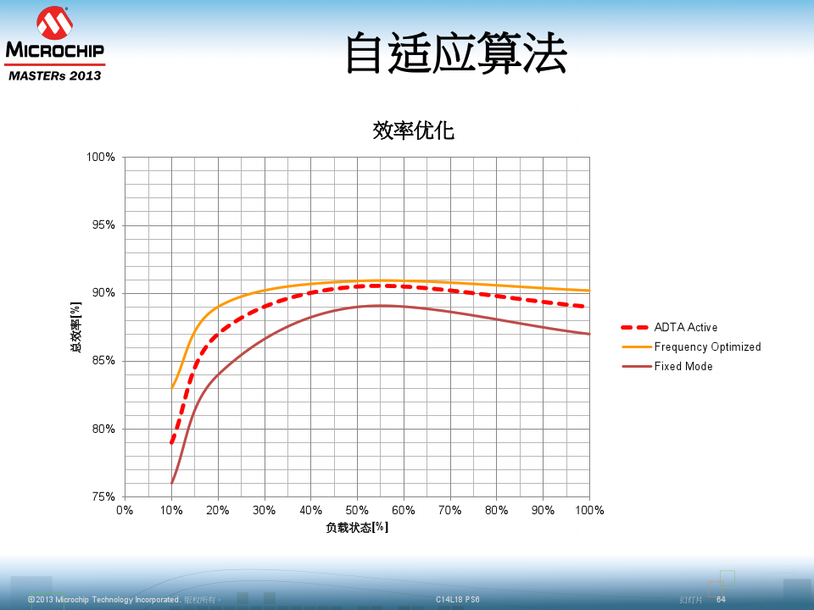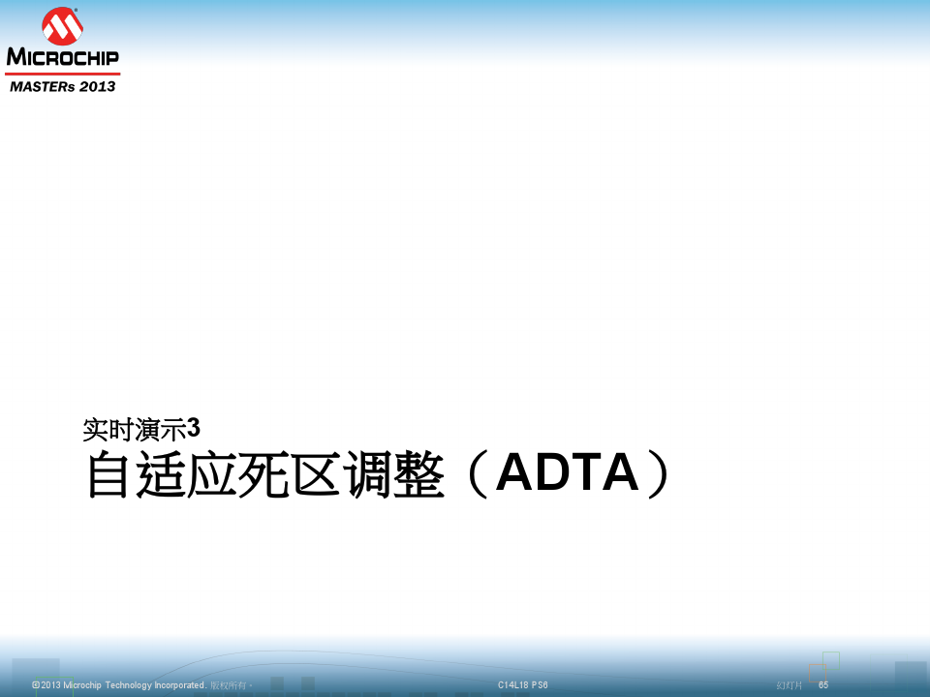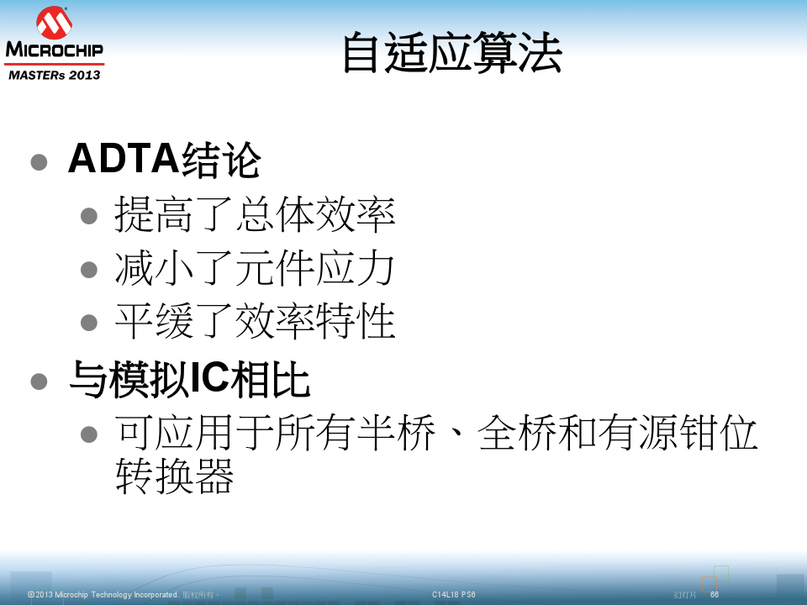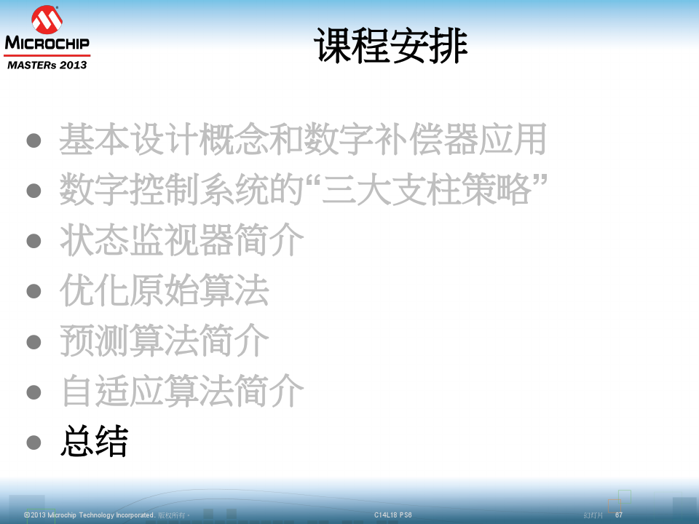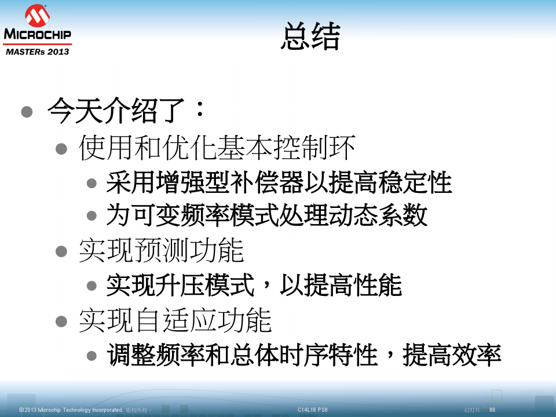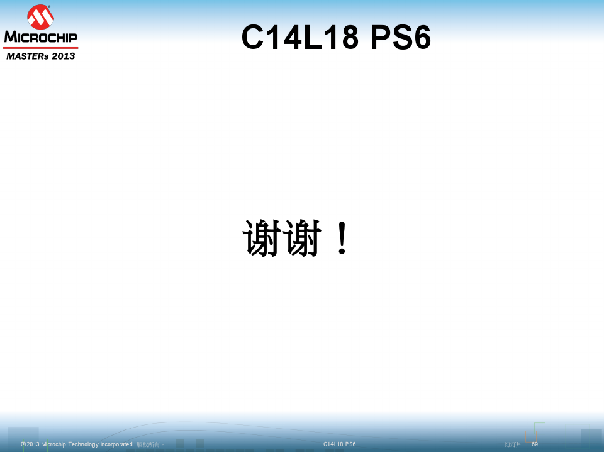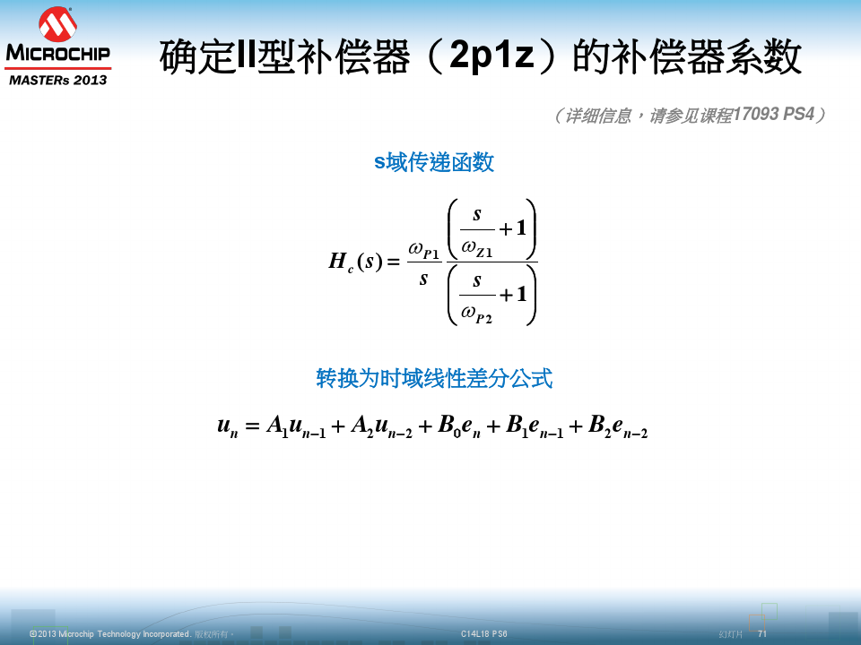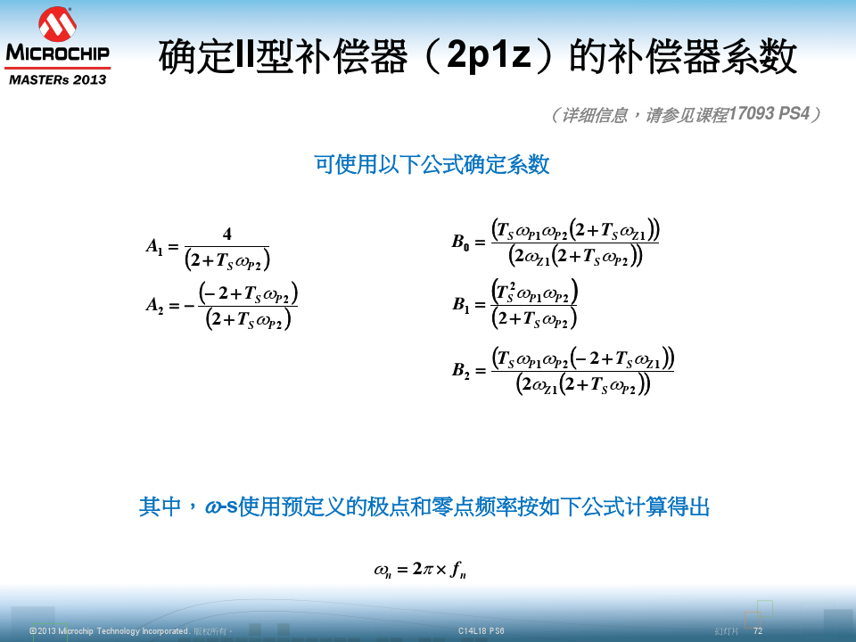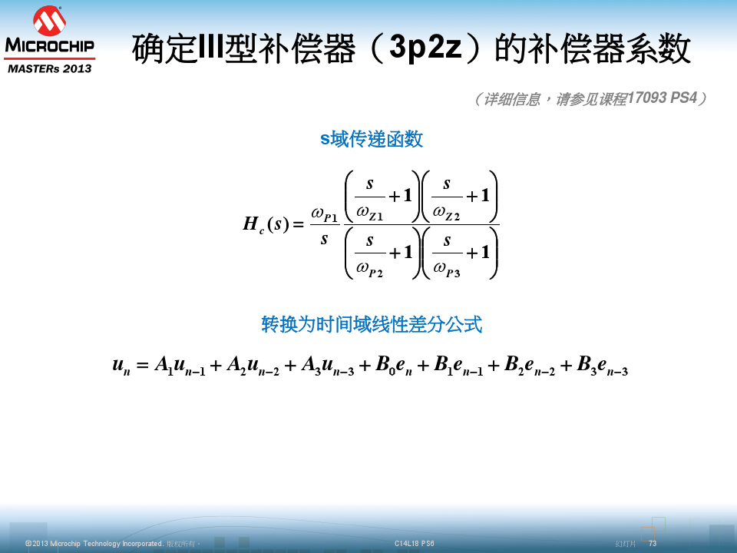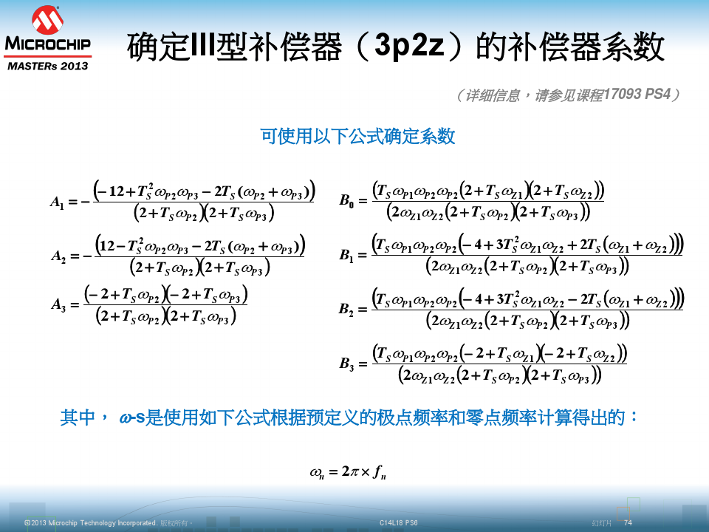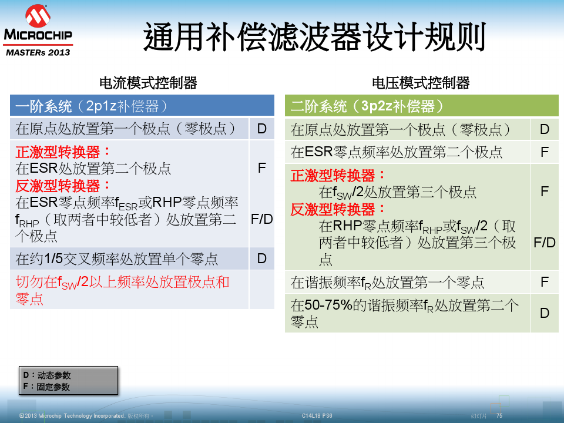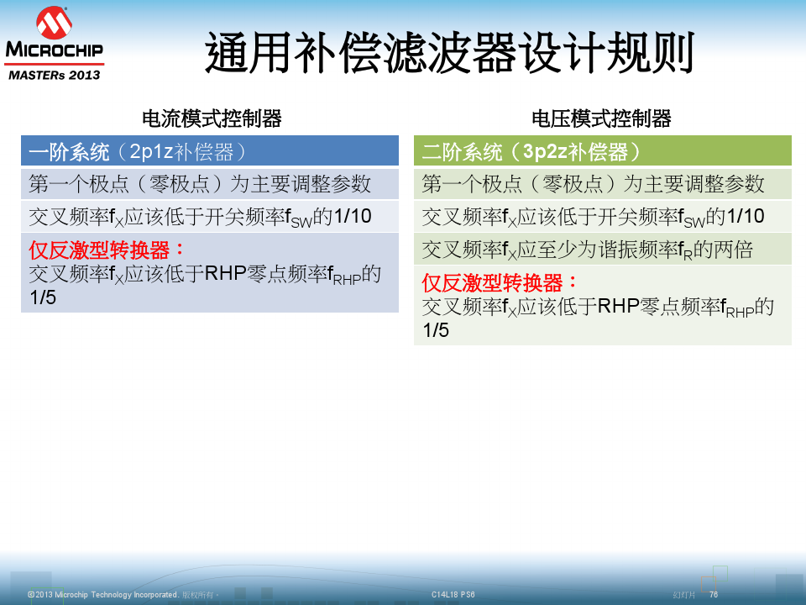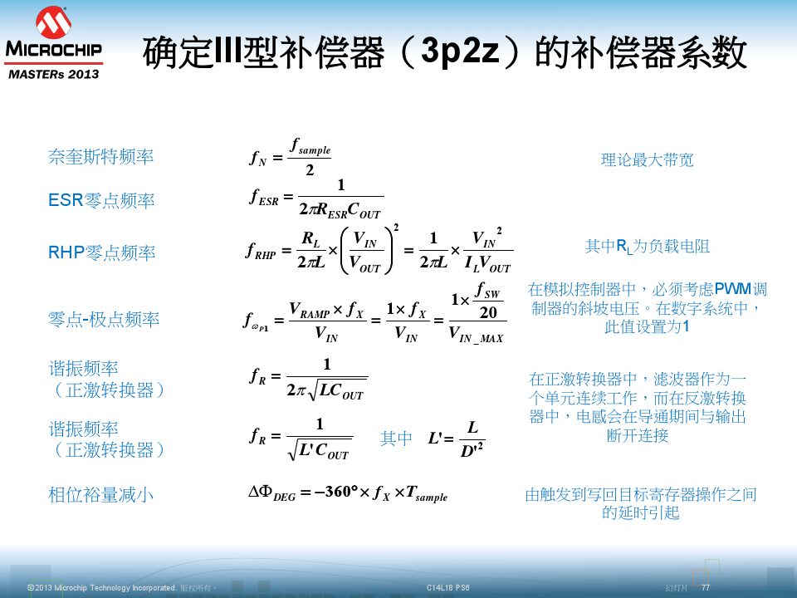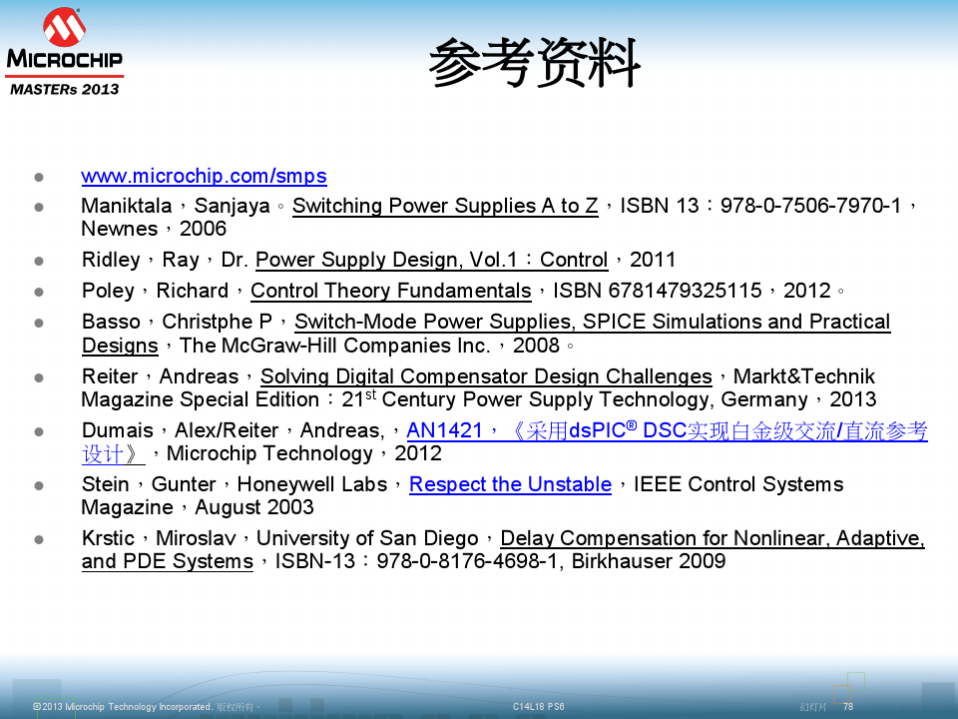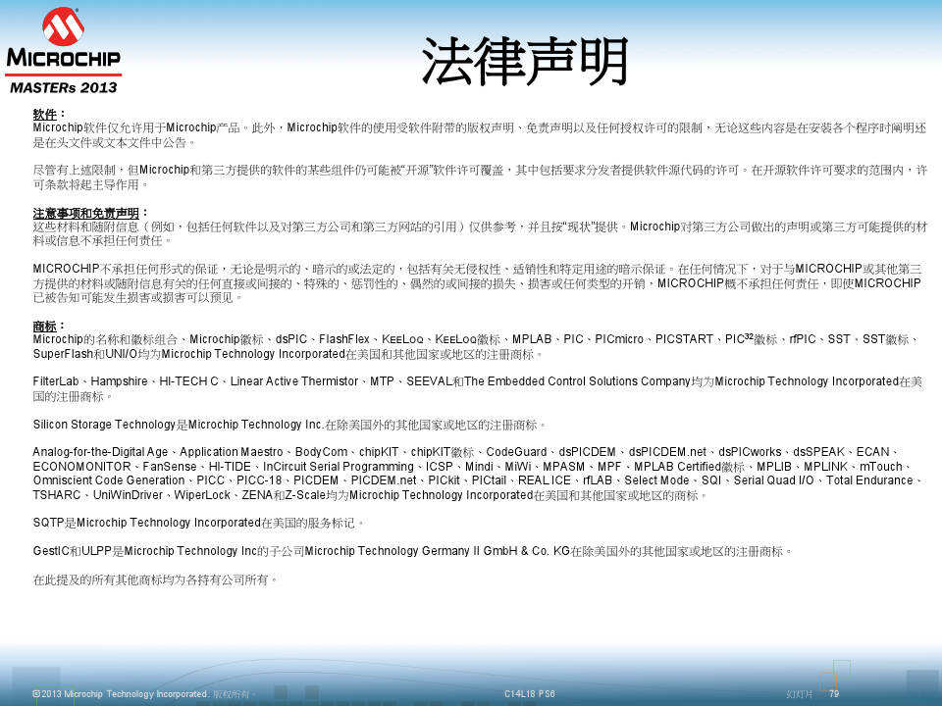

获取文档，使用更方便

VIP免券下载

VIP文档免费下 付费文档8折购 文档格式随意转

[颐格国际德国直供菲尼克斯，优势价格及完善售后服务](http://www.baidu.com/baidu.php?url=Ks00000EAMrnlPLIyVIO5W3XNdAH4xb1SpU-mDRNAJtlGwZD39Q1ynX6XrT1BttF6vw-nIrHQZrVyTFLiXPLl_eBygNLAlG9QIlz2OoQ5DceqDamCEe8l3j-9gh-6jftLrzF8tC8XF2FvcmusQ9YLitEQxaySmvprw74Wv4ZnI7jWSM-QkWEIN9Jjo0w0kM3KTlFpeUc6Tf1qMJZ1PdB-9LRNvcn.7R_jfORM5fHaBjZIS4LknNvIXgZWm3tEA1B_HZ3Sx2h7vM6_o4XPMWu6lRkojPakg3ddqB6.U1Yk0ZDquhN8uvPCmyt-PRu8UzRdwM7dugF4FHNATvN9ThPCFHNAuANhmgN_IaRdwM7dugF40ZfqVtUD3UOQzehOJoMmVXxRV0KGUHYdP1n0Iybq0ZKGujY1PsKWpyfqn0KBpHYs0AuY5H00TA6qn0KET1Ys0AFL5H00UMfqn0K1XWY0ThIYmyTqn0K8IM0qna3snj0snj0sn0K-ThTqn0KYTh7buHYdrj0knjc0mhwGujY1P1TvnYDdPRNjPWc1nWDvrjm4PW-anjb3nbRkwDRLwfKbmvPb5fK9TdqGuAnqTZnVUhC0TMfqrHbs0Z7spyfqn0Kkmv-b5H00mycqn7ts0ZKs5H00Ugws5H00uAwETjYs0ZFJ5H00IZN15HRzPHT3Pj0vP1mvPW6znHm1PHT0mynqnfKsUWYs0ZK9I7qhUA7M5H00ugwGujYVnfK9TLKWm1Ys0ZNspy4Wm1Ys0AuWIgfqn0K9uAu_myTqnfKLuMFEUHY0mMfqnfKzug7Y5HDvnjmsrHmknWb4nHf0Tv-b5H0snjNBPAFWPWNbrjf1m1c0ULfqn0KETMKY5H0WnaPDw-fWnansc10Wna3sc10WwDuRc10WwDuR0AVG5H00Ugfq0AdW5fKVmdqhThqV5fKbmy4dmhNxTAk9Uh-bT1Y0mywkXHvOJoMmVXxRV0K9uZ7Y5H00pgPWUjYs0Z7VIjYs0APzm1YzP16zP6)

[颐格国际德国直供欧洲工控产品，包括菲尼克斯PHOENIX CONTACT，堡盟BAUMER，伊倍达HYPERT](http://www.baidu.com/baidu.php?url=Ks00000EAMrnlPLIyVIO5W3XNdAH4xb1SpU-mDRNAJtlGwZD39Q1ynX6XrT1BttF6vw-nIrHQZrVyTFLiXPLl_eBygNLAlG9QIlz2OoQ5DceqDamCEe8l3j-9gh-6jftLrzF8tC8XF2FvcmusQ9YLitEQxaySmvprw74Wv4ZnI7jWSM-QkWEIN9Jjo0w0kM3KTlFpeUc6Tf1qMJZ1PdB-9LRNvcn.7R_jfORM5fHaBjZIS4LknNvIXgZWm3tEA1B_HZ3Sx2h7vM6_o4XPMWu6lRkojPakg3ddqB6.U1Yk0ZDquhN8uvPCmyt-PRu8UzRdwM7dugF4FHNATvN9ThPCFHNAuANhmgN_IaRdwM7dugF40ZfqVtUD3UOQzehOJoMmVXxRV0KGUHYdP1n0Iybq0ZKGujY1PsKWpyfqn0KBpHYs0AuY5H00TA6qn0KET1Ys0AFL5H00UMfqn0K1XWY0ThIYmyTqn0K8IM0qna3snj0snj0sn0K-ThTqn0KYTh7buHYdrj0knjc0mhwGujY1P1TvnYDdPRNjPWc1nWDvrjm4PW-anjb3nbRkwDRLwfKbmvPb5fK9TdqGuAnqTZnVUhC0TMfqrHbs0Z7spyfqn0Kkmv-b5H00mycqn7ts0ZKs5H00Ugws5H00uAwETjYs0ZFJ5H00IZN15HRzPHT3Pj0vP1mvPW6znHm1PHT0mynqnfKsUWYs0ZK9I7qhUA7M5H00ugwGujYVnfK9TLKWm1Ys0ZNspy4Wm1Ys0AuWIgfqn0K9uAu_myTqnfKLuMFEUHY0mMfqnfKzug7Y5HDvnjmsrHmknWb4nHf0Tv-b5H0snjNBPAFWPWNbrjf1m1c0ULfqn0KETMKY5H0WnaPDw-fWnansc10Wna3sc10WwDuRc10WwDuR0AVG5H00Ugfq0AdW5fKVmdqhThqV5fKbmy4dmhNxTAk9Uh-bT1Y0mywkXHvOJoMmVXxRV0K9uZ7Y5H00pgPWUjYs0Z7VIjYs0APzm1YzP16zP6)

广告[查看详情](http://www.baidu.com/baidu.php?url=Ks00000EAMrnlPLIyVIO5W3XNdAH4xb1SpU-mDRNAJtlGwZD39Q1ynX6XrT1BttF6vw-nIrHQZrVyTFLiXPLl_eBygNLAlG9QIlz2OoQ5DceqDamCEe8l3j-9gh-6jftLrzF8tC8XF2FvcmusQ9YLitEQxaySmvprw74Wv4ZnI7jWSM-QkWEIN9Jjo0w0kM3KTlFpeUc6Tf1qMJZ1PdB-9LRNvcn.7R_jfORM5fHaBjZIS4LknNvIXgZWm3tEA1B_HZ3Sx2h7vM6_o4XPMWu6lRkojPakg3ddqB6.U1Yk0ZDquhN8uvPCmyt-PRu8UzRdwM7dugF4FHNATvN9ThPCFHNAuANhmgN_IaRdwM7dugF40ZfqVtUD3UOQzehOJoMmVXxRV0KGUHYdP1n0Iybq0ZKGujY1PsKWpyfqn0KBpHYs0AuY5H00TA6qn0KET1Ys0AFL5H00UMfqn0K1XWY0ThIYmyTqn0K8IM0qna3snj0snj0sn0K-ThTqn0KYTh7buHYdrj0knjc0mhwGujY1P1TvnYDdPRNjPWc1nWDvrjm4PW-anjb3nbRkwDRLwfKbmvPb5fK9TdqGuAnqTZnVUhC0TMfqrHbs0Z7spyfqn0Kkmv-b5H00mycqn7ts0ZKs5H00Ugws5H00uAwETjYs0ZFJ5H00IZN15HRzPHT3Pj0vP1mvPW6znHm1PHT0mynqnfKsUWYs0ZK9I7qhUA7M5H00ugwGujYVnfK9TLKWm1Ys0ZNspy4Wm1Ys0AuWIgfqn0K9uAu_myTqnfKLuMFEUHY0mMfqnfKzug7Y5HDvnjmsrHmknWb4nHf0Tv-b5H0snjNBPAFWPWNbrjf1m1c0ULfqn0KETMKY5H0WnaPDw-fWnansc10Wna3sc10WwDuRc10WwDuR0AVG5H00Ugfq0AdW5fKVmdqhThqV5fKbmy4dmhNxTAk9Uh-bT1Y0mywkXHvOJoMmVXxRV0K9uZ7Y5H00pgPWUjYs0Z7VIjYs0APzm1YzP16zP6&ck=8775.5.116.1037.745.799.330.2086)

版权说明：本文档由用户提供并上传，收益归属内容提供方，若内容存在侵权，请进行举报或认领

下载文档

VIP去广告

**你可能关注的内容**



[颐格国际德国直供菲尼克斯，优势价格及完善售后服务](http://www.baidu.com/baidu.php?url=Ks00000EAMrnlPLIyM9jbPhztT0J5zpN4JmSjJwkYs7NDvGMU44uUpx8jOYNqQP2Bgj1SN4YMpZ4NKqgrvpe-L8p5AfHsuHDr7YvJZ5Jm8PsoT966OUYugS8fwQgiONKvViH1oLfY7A5e73ziQ6QtZxwJiR1ZqE8CVWgPCCgX4_J_9tq03TgfrwpNd9yCRicyKmsro-sT9dHKNAK7KHEC0465Gna.DR_jfORM5fHaBjZIS4LknNvIXgZWm3tEA1B_HAW0heKCHzkF379h9movUSPB60.U1Yk0ZDq0ZfqVtUD3UOQzehOJoMmVXxRV0KGUHYdn1b0Iybq0ZKGujY1PsKWpyfqn0KBpHYs0AuY5H00TA6qn0KET1Ys0AFL5H00UMfqn0K1XWY0ThIYmyTqn0K8IM0qna3snj0snj0sn0K-ThTqn0KYTh7buHYdrj0knjc0mhwGujY1P1TvnYDdPRNjPWc1nWDvrjm4PW-anjb3nbRkwDRLwfKbmvPb5fK9TdqGuAnqTZnVmLf0TMfqrHbs0Z7spyfqn0Kkmv-b5H00mycqn7ts0ZKs5H00Ugws5H00uAwETjYs0ZFJ5H00IZN15HRzPHT3Pj0vP1mvPW6znHm1PHT0mynqnfKsUWYs0ZK9I7qhUA7M5H00ugwGujYVnfK9TLKWm1Ys0ZNspy4Wm1Ys0AuWIgfqn0K9uAu_myTqnfKLuMFEUHY0mMfqnfKzug7Y5HDvnjmsrHmknWb4P1D0Tv-b5H0snjNBPAFWPWRduAPhPyR0ULfqn0KETMKY5H0WnaPDw-fWnansc10Wna3sc10WwDuRc10WwDuR0AVG5H00UgfqnW0vn6KVm1YknjmdrHb4n10kP0KVmdqhThqV5H00uA78IyF-gLK_my4GuZnqn0K9uZ745USJ8IBd4qiY0A7bTgfqn0KGTvP_5H00TydY5H00mLFW5HDsnWmY)广告

[颐格国际德国直供欧洲工控产品，包括菲尼克斯PHOENIX CONTACT，堡盟BAUMER，伊倍达HYPERT](http://www.baidu.com/baidu.php?url=Ks00000EAMrnlPLIyM9jbPhztT0J5zpN4JmSjJwkYs7NDvGMU44uUpx8jOYNqQP2Bgj1SN4YMpZ4NKqgrvpe-L8p5AfHsuHDr7YvJZ5Jm8PsoT966OUYugS8fwQgiONKvViH1oLfY7A5e73ziQ6QtZxwJiR1ZqE8CVWgPCCgX4_J_9tq03TgfrwpNd9yCRicyKmsro-sT9dHKNAK7KHEC0465Gna.DR_jfORM5fHaBjZIS4LknNvIXgZWm3tEA1B_HAW0heKCHzkF379h9movUSPB60.U1Yk0ZDq0ZfqVtUD3UOQzehOJoMmVXxRV0KGUHYdn1b0Iybq0ZKGujY1PsKWpyfqn0KBpHYs0AuY5H00TA6qn0KET1Ys0AFL5H00UMfqn0K1XWY0ThIYmyTqn0K8IM0qna3snj0snj0sn0K-ThTqn0KYTh7buHYdrj0knjc0mhwGujY1P1TvnYDdPRNjPWc1nWDvrjm4PW-anjb3nbRkwDRLwfKbmvPb5fK9TdqGuAnqTZnVmLf0TMfqrHbs0Z7spyfqn0Kkmv-b5H00mycqn7ts0ZKs5H00Ugws5H00uAwETjYs0ZFJ5H00IZN15HRzPHT3Pj0vP1mvPW6znHm1PHT0mynqnfKsUWYs0ZK9I7qhUA7M5H00ugwGujYVnfK9TLKWm1Ys0ZNspy4Wm1Ys0AuWIgfqn0K9uAu_myTqnfKLuMFEUHY0mMfqnfKzug7Y5HDvnjmsrHmknWb4P1D0Tv-b5H0snjNBPAFWPWRduAPhPyR0ULfqn0KETMKY5H0WnaPDw-fWnansc10Wna3sc10WwDuRc10WwDuR0AVG5H00UgfqnW0vn6KVm1YknjmdrHb4n10kP0KVmdqhThqV5H00uA78IyF-gLK_my4GuZnqn0K9uZ745USJ8IBd4qiY0A7bTgfqn0KGTvP_5H00TydY5H00mLFW5HDsnWmY)

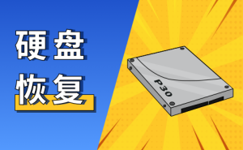

[硬盘文件数据恢复-一键恢复硬盘数据-免费下载](http://www.baidu.com/baidu.php?url=Ks00000EAMrnlPLIyJXMMDPjPyzycXmwUOk4f7Gnp_nbjl7gmpKs5KgJTEH2um443OCBvl-Blw-Fu97rUQFD0f9mGl_XDUHQ90szis-JsC6Un2mGhgmkyZWFlZYB5yfl0N3jv7SShXHr-JQTeyjK3LKkaK2YQ84iuDoVrNf3txYGA8wVwLbu-DPkApe5KvwdncQCpn36Yf73S_t5ly3gJyZ31Mog.Db_NR2Ar5Od663rj6tJMlbkd54cQhpjnzmgxfhUwMY51mvm_qerQ0_HAW0heKCHzkF379h9mzIMWEtN0.U1Yz0ZDq0ZfqYeQ71neDE5e2OUeI8qp3V0KGUHYkn1cz0ZNG5fKspyfqn1T0mv-b5H00mhbqn0KhIjYs0ZKC5H00ULnqn0KBI1Ys0A4Y5H00TLCq0ZFMIA7M5H00UMus5H08nj0snj0snj00ugFM5H00IZF9uARqn0KBuA-b5HnLP1m1fHRdwRnvnWnznHm3PWbvrRcsrH6zwH7DwHI70AwWmvfq0A71gv-bm1dsTzdWI0KEm1Yk0ZFY5Hb4n0KkTA-b5H00TyPGujYs0A7B5HKxn0KsTjYs0AdYTjYs0AwbUL0qn0KzpWYs0ZwdT1YYn1DLn16sPjmLn1DzP1TkP1fY0A7W5HD0TA3qn0Ksmgwxuhk9u1Ys0ANYpyfqQHD0mgPsmvnqn0KdTA-8mvnqn0KhmLNY5H00mywhUA7M5HD0IvuzUvYq0AFY5H00ThNkIjYkPW0vnjbvnHc4rHTk0ZPGujYsnj0dmWwBm1mdPywWuWN-0AqY5HD0ULFsIjYzc10WPBnkc1cvrj0srjfzPanvPHnWna3sc1DWninsczY0pvbqn0KVIjYznjmz0AdW5HD4Pjm4nH03PHmv0AdWgvuzUvYqn0Kbmy4dmhNxTAk9Uh-bT1Ys0A7bTgbqYeQ71QEy8Qf0mywkIjYs0A-1mvsqn0KkUgfqn0KWThnqnHn3rHD)广告

[硬盘文件数据恢复，用嗨格式数据恢复大师，快速扫描硬盘，一键恢复硬盘丢失数据。](http://www.baidu.com/baidu.php?url=Ks00000EAMrnlPLIyJXMMDPjPyzycXmwUOk4f7Gnp_nbjl7gmpKs5KgJTEH2um443OCBvl-Blw-Fu97rUQFD0f9mGl_XDUHQ90szis-JsC6Un2mGhgmkyZWFlZYB5yfl0N3jv7SShXHr-JQTeyjK3LKkaK2YQ84iuDoVrNf3txYGA8wVwLbu-DPkApe5KvwdncQCpn36Yf73S_t5ly3gJyZ31Mog.Db_NR2Ar5Od663rj6tJMlbkd54cQhpjnzmgxfhUwMY51mvm_qerQ0_HAW0heKCHzkF379h9mzIMWEtN0.U1Yz0ZDq0ZfqYeQ71neDE5e2OUeI8qp3V0KGUHYkn1cz0ZNG5fKspyfqn1T0mv-b5H00mhbqn0KhIjYs0ZKC5H00ULnqn0KBI1Ys0A4Y5H00TLCq0ZFMIA7M5H00UMus5H08nj0snj0snj00ugFM5H00IZF9uARqn0KBuA-b5HnLP1m1fHRdwRnvnWnznHm3PWbvrRcsrH6zwH7DwHI70AwWmvfq0A71gv-bm1dsTzdWI0KEm1Yk0ZFY5Hb4n0KkTA-b5H00TyPGujYs0A7B5HKxn0KsTjYs0AdYTjYs0AwbUL0qn0KzpWYs0ZwdT1YYn1DLn16sPjmLn1DzP1TkP1fY0A7W5HD0TA3qn0Ksmgwxuhk9u1Ys0ANYpyfqQHD0mgPsmvnqn0KdTA-8mvnqn0KhmLNY5H00mywhUA7M5HD0IvuzUvYq0AFY5H00ThNkIjYkPW0vnjbvnHc4rHTk0ZPGujYsnj0dmWwBm1mdPywWuWN-0AqY5HD0ULFsIjYzc10WPBnkc1cvrj0srjfzPanvPHnWna3sc1DWninsczY0pvbqn0KVIjYznjmz0AdW5HD4Pjm4nH03PHmv0AdWgvuzUvYqn0Kbmy4dmhNxTAk9Uh-bT1Ys0A7bTgbqYeQ71QEy8Qf0mywkIjYs0A-1mvsqn0KkUgfqn0KWThnqnHn3rHD)

相关推荐

开关电源传导+EMI+建模和模型有效性评估

4.5分

1286阅读

数字开关电源基础(凌特资料)

4.5分

6737阅读

数控太阳能逆变电源设计细节

3.5分

192阅读

数字电源

2.2分

4066阅读

数字电源解决方案

4.5分

4728阅读

如何让模拟工程师实现数字电源转换 dsPIC30F2020

4.4分

642阅读

高二数学暑假作业三综合卷

4.2分

3344阅读

19.1.1 第1课时 变量

4.1分

2.4W 阅读

青骄第二课堂禁毒初一初二初三答案含有期末

4.2分

68.4W 阅读

暂无评论



0 /240

关于作者

qizhiguang954

文库新人

文档

粉丝

等级

进入专区

文档格式转换服务

PDF格式任意转换,您的私人办公助手

PDF转Word

PPT转PDF

相关搜索

非线性反推控制算法

已有104万用户搜索

数字电源算法

已有168万用户搜索

非线性控制算法

已有117万用户搜索

数字式非线性转换

已有298万用户搜索

相关文档



[颐格国际德国直供菲尼克..](http://www.baidu.com/baidu.php?url=Ks00000EAMrnlPLIyM9jbPhztT0J5zpN4JmSjJwkYs7NDvGMU44uUpx8jOYNqQP2Bgj1SN4YMpZ4NKqgrvpe-L8p5AfHsuHDr7YvJZ5Jm8PsoT966OUYugS8fwQgiONKvViH1oLfY7A5e73ziQ6QtZxwJiR1ZqE8CVWgPCCgX4_J_9tq03TgfrwpNd9yCRicyKmsro-sT9dHKNAK7KHEC0465Gna.DR_jfORM5fHaBjZIS4LknNvIXgZWm3tEA1B_HAW0heKCHzkF379h9movUSPB60.U1Yk0ZDq0ZfqVtUD3UOQzehOJoMmVXxRV0KGUHYdn1b0Iybq0ZKGujY1PsKWpyfqn0KBpHYs0AuY5H00TA6qn0KET1Ys0AFL5H00UMfqn0K1XWY0ThIYmyTqn0K8IM0qna3snj0snj0sn0K-ThTqn0KYTh7buHYdrj0knjc0mhwGujY1P1TvnYDdPRNjPWc1nWDvrjm4PW-anjb3nbRkwDRLwfKbmvPb5fK9TdqGuAnqTZnVmLf0TMfqrHbs0Z7spyfqn0Kkmv-b5H00mycqn7ts0ZKs5H00Ugws5H00uAwETjYs0ZFJ5H00IZN15HRzPHT3Pj0vP1mvPW6znHm1PHT0mynqnfKsUWYs0ZK9I7qhUA7M5H00ugwGujYVnfK9TLKWm1Ys0ZNspy4Wm1Ys0AuWIgfqn0K9uAu_myTqnfKLuMFEUHY0mMfqnfKzug7Y5HDvnjmsrHmknWb4P1D0Tv-b5H0snjNBPAFWPWRduAPhPyR0ULfqn0KETMKY5H0WnaPDw-fWnansc10Wna3sc10WwDuRc10WwDuR0AVG5H00UgfqnW0vn6KVm1YknjmdrHb4n10kP0KVmdqhThqV5H00uA78IyF-gLK_my4GuZnqn0K9uZ745USJ8IBd4qiY0A7bTgfqn0KGTvP_5H00TydY5H00mLFW5HDsnWmY)

广告234阅读

预测控制非线性神经网络LM算法论文

4.4分

82阅读

非线性方程不动点算法及研究

4.4分

41阅读

信赖域算法---非线性优化问题

4.5分

694阅读

精品课程

初中数学数据的收集整理与描述知识点教学

老闫HSE

￥10

诸强新--专业销售实战技能

德鲁克管理课堂

￥260

诸强新--总经理实战营销系列之营销 赢

德鲁克管理课堂

￥120

高中数学思维 第一季

点通互动微课堂

￥169

VIP去广告

**相关资源**

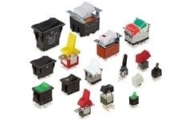

[NKK SWITCHES 电源开关](http://www.baidu.com/baidu.php?url=Ks00000EAMrnlPLIy9lQ7LhULavShZdVTLFmjjv7yFJsugYCbJLmy51T51Agm9T8iRuwQQBC8aIhXCHx1W-FK1in0PfraiaSQX_sLvircba2LOGZ-T8Ot3vMCLYRhOW_4bSsxbMihvRJJrLSZ101dmO4sGOQM40lPKJ_K0D3vDZeksI2dsn9vsBEwOsSOmKICRl2G50VNeo4KqrxOB9SVQ5okmmm.7D_NR2Ar5Od663rj6tC8LVW3ZYcpbkYsyksxlLfqJuC37BmYmDLmPaXyF50_nYQZuE_L470.U1Yk0ZDq0ZfqVXxRVQSJ8I60pyYqnHnzP0KdpHY0TA-b5HnL0APGujYs0AFG5H00uMfqn0KspjYs0Aq15H00mMTqn0K8IjYs0ZPl5fKzuLw9u1Ys0A4vTjYsQW0snj0snj0s0ANzu1Ys0Zwzmyw-5HR3njDsPfKBuA-b5HnLP1m1fHRdwRnvnWnznHm3PWbvrRcsrH6zwH7DwHI70AwWmvfq0A71gv-bm1dsTzdWI0KzIjY4rH00TgKGujYs0Z7Wpyfqn0K9mWYsg100TZ0qn0KVIZ0qn0KbuAqs5H00ThCqn0KYIgnqnHc3njDdnHRLrHnznHcvnHczPHD0mynqnfKsUWYs0ZK9I7qhUA7M5H00ugwGujYVnfK9TLKWm1Ys0ZNspy4Wm1Ys0AuWIgfqn0K9uAu_myTqnfKLuMFEUHY0mMfqn0Kzug7Y5HDvnjmsrHmknWb4P1D0Tv-b5H0snjNBPAFWPWRduAPhPyR0ULfqn0KETMKY5H0WnaPDw-fWnansc10Wna3sc10WwDuRc10WwDuR0AVG5H00UgfqnW0vn6KVm1YvPWmsn1f4PjRd0AdWgvuzUvYqn0Kbmy4dmhNxTAk9Uh-bT1Ys0A7bTgbqElJ4vQgMdQf0mywkIjYs0A-1mvsqn0KkUgfqn0KWThnqPjnknWR)

[世界知名品牌NKK，专注工业开关66年，欢迎在线垂询免费样品](http://www.baidu.com/baidu.php?url=Ks00000EAMrnlPLIy9lQ7LhULavShZdVTLFmjjv7yFJsugYCbJLmy51T51Agm9T8iRuwQQBC8aIhXCHx1W-FK1in0PfraiaSQX_sLvircba2LOGZ-T8Ot3vMCLYRhOW_4bSsxbMihvRJJrLSZ101dmO4sGOQM40lPKJ_K0D3vDZeksI2dsn9vsBEwOsSOmKICRl2G50VNeo4KqrxOB9SVQ5okmmm.7D_NR2Ar5Od663rj6tC8LVW3ZYcpbkYsyksxlLfqJuC37BmYmDLmPaXyF50_nYQZuE_L470.U1Yk0ZDq0ZfqVXxRVQSJ8I60pyYqnHnzP0KdpHY0TA-b5HnL0APGujYs0AFG5H00uMfqn0KspjYs0Aq15H00mMTqn0K8IjYs0ZPl5fKzuLw9u1Ys0A4vTjYsQW0snj0snj0s0ANzu1Ys0Zwzmyw-5HR3njDsPfKBuA-b5HnLP1m1fHRdwRnvnWnznHm3PWbvrRcsrH6zwH7DwHI70AwWmvfq0A71gv-bm1dsTzdWI0KzIjY4rH00TgKGujYs0Z7Wpyfqn0K9mWYsg100TZ0qn0KVIZ0qn0KbuAqs5H00ThCqn0KYIgnqnHc3njDdnHRLrHnznHcvnHczPHD0mynqnfKsUWYs0ZK9I7qhUA7M5H00ugwGujYVnfK9TLKWm1Ys0ZNspy4Wm1Ys0AuWIgfqn0K9uAu_myTqnfKLuMFEUHY0mMfqn0Kzug7Y5HDvnjmsrHmknWb4P1D0Tv-b5H0snjNBPAFWPWRduAPhPyR0ULfqn0KETMKY5H0WnaPDw-fWnansc10Wna3sc10WwDuRc10WwDuR0AVG5H00UgfqnW0vn6KVm1YvPWmsn1f4PjRd0AdWgvuzUvYqn0Kbmy4dmhNxTAk9Uh-bT1Ys0A7bTgbqElJ4vQgMdQf0mywkIjYs0A-1mvsqn0KkUgfqn0KWThnqPjnknWR)

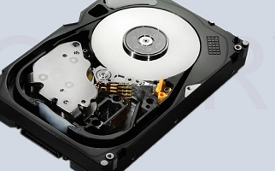

[呼和浩特 硬盘恢复 硬盘恢复专家](http://www.baidu.com/baidu.php?url=Ks00000EAMrnlPLIyWvgk0bIMIAmHQ8BO2U3AFIsUWpvt-84yJawewnDZciMhC26qYWQuknB32KzCkXYVnvtX9jOa47Zdw1tn8kyG0NXUV2HkBtxVHauEfCJQ3C6ne7FPFnG-oqhG_mpfcZB4OJzwLmRt_-YB3RkhiL4ht-20pYuo66ta5gbBkWE6-ONhsBnr2h7uQdSOM1DU0DIWB0QzF0lA96u.DD_auM784cQhpjnzmgxfhUwKvGYfyIbaknpnaU_A95QDM6yAp7WGozIrkf.U1Yz0ZDq0Zfq8Eil1UoA1P6-nWjH__gn8qp3V0KGUHYkn1cY0ZNG5fKspyfqn1T0mv-b5H00mhbqn0KhIjYs0ZKC5H00ULnqn0KBI1Ys0A4Y5H00TLCq0ZFMIA7M5H00UMus5H08nj0snj0snj00ugFM5H00IZF9uARqPHTsPj0z0AFbpyfqn1TLPWPKPHN7f1mzn1ckPW6vrHm4fW04rjF7nRw7PYR0uAPWujY0mgPxpywW5gK1QyPY0ZFY5Hb4n0KkTA-b5H00TyPGujYs0A7B5HKxn0KsTjYs0AdYTjYs0AwbUL0qnfKzpWYs0ZwdT1YdnH64nHnLPH0kPjbvrjczP10v0A7W5HD0TA3qn0Ksmgwxuhk9u1Ys0ANYpyfqQHD0mgPsmvnqn0KdTA-8mvnqn0KhmLNY5H00mywhUA7M5HD0IvuzUvYq0AFY5H00XZPYIHYzP1mYP10sPfKzug7Y5HDvnjmsrHmknWb4P1D0Tv-b5H0snjNBPAFWPWRduAPhPyR0ULfqn0KETMKY5H0WnaPDw-fWnansc10Wna3sc10WwDuRc10WwDuR0AVG5H00UgfqnW0vn6KVm1Y4rH6snj6Yrj6s0AdWgvuzUvYqn0Kbmy4dmhNxTAk9Uh-bT1Ys0A7bTgbqYeQ71QEy8Qf0mywkIjYs0A-1mvsqn0KkUgfqn0KWThnqn1n1nf&xst=m1YKmWY1P1TvnYDdPRNjPWc1nWDvrjm4PW-anjb3nbRkwDRLwf715HDvnjmsrHmkn1DsPHD1PH9xnHnzP7tk0gTq8Eil1UoA1P66YeQ71QEy8QfKTHdbuyu9IykYgL7dugF4g1D4rjnKIHYzP1mYP10sPf7Y5HDvnjmsrHmkn10KUgDqnfcs0VrzkTzedoBY0yPC5yuWgLKW0HfLPjTvrjTsnf&word=)

[呼和浩特 硬盘恢复 专业修复数据，手把手教你远程操作，硬盘损坏恢复数据](http://www.baidu.com/baidu.php?url=Ks00000EAMrnlPLIyWvgk0bIMIAmHQ8BO2U3AFIsUWpvt-84yJawewnDZciMhC26qYWQuknB32KzCkXYVnvtX9jOa47Zdw1tn8kyG0NXUV2HkBtxVHauEfCJQ3C6ne7FPFnG-oqhG_mpfcZB4OJzwLmRt_-YB3RkhiL4ht-20pYuo66ta5gbBkWE6-ONhsBnr2h7uQdSOM1DU0DIWB0QzF0lA96u.DD_auM784cQhpjnzmgxfhUwKvGYfyIbaknpnaU_A95QDM6yAp7WGozIrkf.U1Yz0ZDq0Zfq8Eil1UoA1P6-nWjH__gn8qp3V0KGUHYkn1cY0ZNG5fKspyfqn1T0mv-b5H00mhbqn0KhIjYs0ZKC5H00ULnqn0KBI1Ys0A4Y5H00TLCq0ZFMIA7M5H00UMus5H08nj0snj0snj00ugFM5H00IZF9uARqPHTsPj0z0AFbpyfqn1TLPWPKPHN7f1mzn1ckPW6vrHm4fW04rjF7nRw7PYR0uAPWujY0mgPxpywW5gK1QyPY0ZFY5Hb4n0KkTA-b5H00TyPGujYs0A7B5HKxn0KsTjYs0AdYTjYs0AwbUL0qnfKzpWYs0ZwdT1YdnH64nHnLPH0kPjbvrjczP10v0A7W5HD0TA3qn0Ksmgwxuhk9u1Ys0ANYpyfqQHD0mgPsmvnqn0KdTA-8mvnqn0KhmLNY5H00mywhUA7M5HD0IvuzUvYq0AFY5H00XZPYIHYzP1mYP10sPfKzug7Y5HDvnjmsrHmknWb4P1D0Tv-b5H0snjNBPAFWPWRduAPhPyR0ULfqn0KETMKY5H0WnaPDw-fWnansc10Wna3sc10WwDuRc10WwDuR0AVG5H00UgfqnW0vn6KVm1Y4rH6snj6Yrj6s0AdWgvuzUvYqn0Kbmy4dmhNxTAk9Uh-bT1Ys0A7bTgbqYeQ71QEy8Qf0mywkIjYs0A-1mvsqn0KkUgfqn0KWThnqn1n1nf&xst=m1YKmWY1P1TvnYDdPRNjPWc1nWDvrjm4PW-anjb3nbRkwDRLwf715HDvnjmsrHmkn1DsPHD1PH9xnHnzP7tk0gTq8Eil1UoA1P66YeQ71QEy8QfKTHdbuyu9IykYgL7dugF4g1D4rjnKIHYzP1mYP10sPf7Y5HDvnjmsrHmkn10KUgDqnfcs0VrzkTzedoBY0yPC5yuWgLKW0HfLPjTvrjTsnf&word=)

广告

相关搜索

非线性反推控制算法

已有104万用户搜索

数字电源算法

已有168万用户搜索

非线性控制算法

已有117万用户搜索

数字式非线性转换

已有298万用户搜索

相关文档



[颐格国际德国直供菲尼克..](http://www.baidu.com/baidu.php?url=Ks00000EAMrnlPLIyM9jbPhztT0J5zpN4JmSjJwkYs7NDvGMU44uUpx8jOYNqQP2Bgj1SN4YMpZ4NKqgrvpe-L8p5AfHsuHDr7YvJZ5Jm8PsoT966OUYugS8fwQgiONKvViH1oLfY7A5e73ziQ6QtZxwJiR1ZqE8CVWgPCCgX4_J_9tq03TgfrwpNd9yCRicyKmsro-sT9dHKNAK7KHEC0465Gna.DR_jfORM5fHaBjZIS4LknNvIXgZWm3tEA1B_HAW0heKCHzkF379h9movUSPB60.U1Yk0ZDq0ZfqVtUD3UOQzehOJoMmVXxRV0KGUHYdn1b0Iybq0ZKGujY1PsKWpyfqn0KBpHYs0AuY5H00TA6qn0KET1Ys0AFL5H00UMfqn0K1XWY0ThIYmyTqn0K8IM0qna3snj0snj0sn0K-ThTqn0KYTh7buHYdrj0knjc0mhwGujY1P1TvnYDdPRNjPWc1nWDvrjm4PW-anjb3nbRkwDRLwfKbmvPb5fK9TdqGuAnqTZnVmLf0TMfqrHbs0Z7spyfqn0Kkmv-b5H00mycqn7ts0ZKs5H00Ugws5H00uAwETjYs0ZFJ5H00IZN15HRzPHT3Pj0vP1mvPW6znHm1PHT0mynqnfKsUWYs0ZK9I7qhUA7M5H00ugwGujYVnfK9TLKWm1Ys0ZNspy4Wm1Ys0AuWIgfqn0K9uAu_myTqnfKLuMFEUHY0mMfqnfKzug7Y5HDvnjmsrHmknWb4P1D0Tv-b5H0snjNBPAFWPWRduAPhPyR0ULfqn0KETMKY5H0WnaPDw-fWnansc10Wna3sc10WwDuRc10WwDuR0AVG5H00UgfqnW0vn6KVm1YknjmdrHb4n10kP0KVmdqhThqV5H00uA78IyF-gLK_my4GuZnqn0K9uZ745USJ8IBd4qiY0A7bTgfqn0KGTvP_5H00TydY5H00mLFW5HDsnWmY)

广告234阅读

预测控制非线性神经网络LM算法论文

4.4分

82阅读

非线性方程不动点算法及研究

4.4分

41阅读

信赖域算法---非线性优化问题

4.5分

694阅读

精品课程

初中数学数据的收集整理与描述知识点教学

老闫HSE

￥10

诸强新--专业销售实战技能

德鲁克管理课堂

￥260

诸强新--总经理实战营销系列之营销 赢

德鲁克管理课堂

￥120

高中数学思维 第一季

点通互动微课堂

￥169

关于我们

关于百度文库

机构/企业资源库

加入我们

个人入驻

机构入驻

文库上传规范

商务合作

商业文档

品牌推广

代理招募

联系我们

文库VIP专属服务号

文库服务号

客服电话：400-921-7005

[客服QQ：800049878](tencent://Message/?Uin=800049878&amp;websiteName=wenku;Menu=yes)

在线反馈

非法有害信息举报

若发现您的权益受到侵害，请立即联系客服，我们会尽快为您处理

京ICP证030173号 京网文[2013]0934-983号 Copyright ©2020 Baidu

|

由 百度云 提供计算服务

|

[使用百度前必读](https://www.baidu.com/duty/)

|

[文库协议](https://wenku.baidu.com/portal/browse/help#help/24)

|

[百度营销](http://e.baidu.com?refer=140)

|

[帮助](https://wenku.baidu.com/portal/browse/help)

|

[网站地图](https://wenku.baidu.com/portal/browse/websitemap)